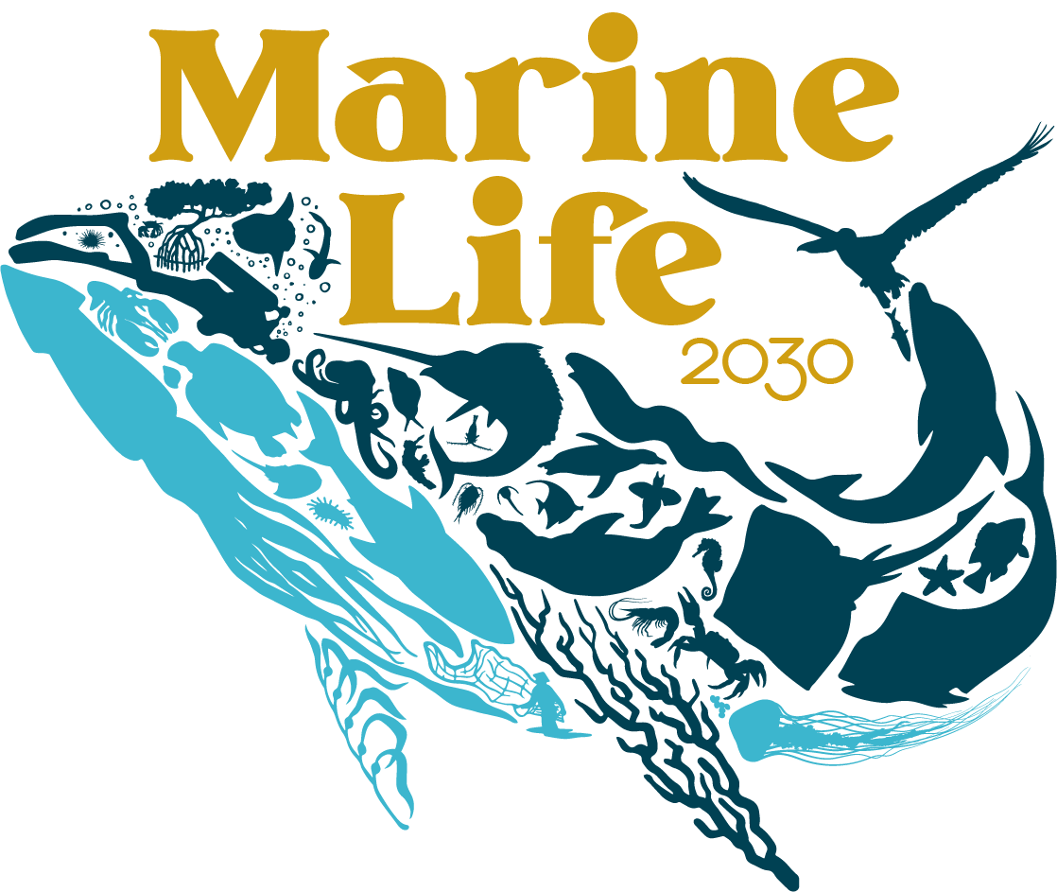
A Programme of the UN Decade of Ocean Science for Sustainable Development
https://marinelife2030.org/

Building global knowledge of marine life for local action in the Ocean Decade

Marine Life 2030 will establish the globally coordinated system to deliver actionable, transdisciplinary knowledge of ocean life to those who need it, promoting human well-being, sustainable development, and ocean conservation. Join us to implement the framework to unite existing and new programs into a global, interoperable network, transforming the observation and forecasting of marine life for the future for the benefit of all people.

The Need
The ocean we want hosts abundant and diverse life that supports humanity’s needs for food, natural products, and good livelihoods. The ocean’s >200,000 species are the engine of ecosystems that provide these benefits. To realize sustainable development we need reliable, accessible information on these species. This requires solving three challenges: (1) today, management of marine living resources relies mainly on proxy variables like temperature, salinity, and topography -- generally without measuring biology itself because most marine species and great swaths of the ocean’s ecosystems remain unstudied; (2) existing data on ocean species are inadequately coordinated, undigitized, of varying quality, and largely inaccessible; and (3) marine biodiversity science and observations are poorly linked to users and communities.

The Vision
By 2030 and beyond, anyone, anywhere, will have access to information on marine species and ecosystems important to local fisheries, culture, health, and livelihoods. We will be able to diagnose how species are shifting with climate change and management interventions, to achieve a sustainable future for nature and people.

The Plan
The science we need to achieve the ocean we want requires transformations in technology, in the culture of science, and in the scale and nature of coordination. Marine Life 2030 will: (1) work with other Ocean Decade Programs and convene stakeholders around the world to co-design, coordinate and finance sustainable marine life observation and applications; (2) leverage emerging innovation in ‘omics, acoustics, imaging, remote sensing, and artificial intelligence to align biodiversity with other ocean parameters; (3) integrate the critical missing pieces into a global, multi-disciplinary and interoperable ocean observation system; and (4) co-deliver solutions, starting with the communities that need them the most.

Marine Life 2030 is an open networking program. Core leadership comes from NOAA/US Integrated Ocean Observing System and the global Marine Biodiversity Observation Network (MBON), along with the Global Ocean Observing System (GOOS), UNEP World Conservation and Monitoring Centre (UNEP-WCMC), Ocean Biodiversity Information System (OBIS), Ocean Best Practices System (OBPS), Group on Earth Observations (GEO), the Future Earth Ocean Knowledge Action Network (Ocean KAN), POGO Biological Observations Working Group; and >60 partners. Marine Life 2030 welcomes new multi-sector collaborators in the Ocean Decade.

IOOS Contact and Co-Lead: Gabrielle Canonico (gabrielle.canonico@noaa.gov)

