ANIMAL TELEMETRY NETWORK (ATN) COORDINATOR REPORT #2 TO BOEM

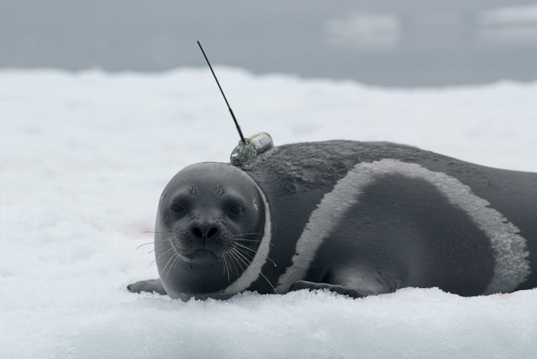

**Photo by Vladimir Burkanov, NOAA**

September 2017 – March 2019  
  
**IAA M16PG00017/P00002**

**IAA M18PG00013**

***Prepared by Bill Woodward, Integrated Systems Solutions, on Contract with the U.S. IOOS Program at NOAA***

TABLE OF CONTENTS

Executive Summary…………………………………………………………………………………………………..………….…………….3

Introduction………………………………………………………………………………………………………………………….……………5

I. Building Alliances and Collaborations…………………………………………………..…………………..…………………….5

Establishing Credibility and Earning Community Trust

Telemetry Asset Inventory

ATN Presentations to the Community by the Coordinator

II. Providing Telemetry Data Aggregation, Management, Display and Delivery………………………............7

Data Aggregation, Management, Delivery

ATN DAC Data Coordinator Hired

Regional Acoustic Data Nodes

III. Funding Baseline Animal Telemetry Observations………………………………………………………………………..8

ATN Workshops

Telemetry Infrastructure Projects being Funded

APPENDIX A: ATN FY-18 Funding structure

APPENDIX B: Workshop Reports

APPENDIX C: ATN Coordinator Travel Summary

APPENDIX D: From the ATN Wheelhouse

EXECUTIVE SUMMARY

Gathering information on the behavior and movement of marine animals is an essential part of the responsibilities of our national agencies charged with protecting endangered and threatened marine species as well as providing ecosystem-based management of commercially harvested marine resources. This data and information, collected remotely via acoustic and satellite telemetry techniques, assists specifically with implementing the Endangered Species Act, the Marine Mammal Protection Act and the Fur Seal Act, performing National Environmental Policy Act analyses, providing Incidental Harassment Authorizations and conducting Section 7 Interagency Consultations.

The data is applied broadly to assess marine animal habitat use, detect changes in their migratory routes in relation to oil & gas activities and climate variability, monitor changing movement patterns with increasing ship traffic to assist with marine mammal avoidance, and improve abundance/population estimates to ensure both the conservation and sustainable management of commercially harvested species as well as responsibly sustained subsistence livelihoods.

The multi-agency U.S. Animal Telemetry Network (ATN) has been established to provide unity, stability and continuity to the national infrastructure that facilitates the collection, management and availability of this marine animal telemetry data. To accomplish its mission, the ATN is being implemented in three Phases and on these three foundational pillars: ***1) Building Alliances and Collaborations, 2) Providing Telemetry Data Aggregation, Management, Display and Delivery, and 3) Funding High Priority Regional Baseline Animal Telemetry Observations.***

As reported in **ATN Coordinator Report #1 to BOEM**, and In accordance with the 5-year Implementation Plan (IP) approved by OSTP in December 2016, **Phase I** of the implementation began in the first quarter CY 2016 with the hiring of the full-time ATN network coordinator, Bill Woodward, with primary emphasis during Phase I on forming alliances/collaborations, creating governance and implementing a research-based ATN data management/delivery vision. ATN governance is executed by a Steering Group (SG) that provides guidance and leadership on the development and implementation of the ATN. The SG has 13 members with representatives from 9 Federal agencies and four non-federal institutions. The ATN data management vision is to provide a regionally distributed data collection, management and sharing capacity that builds on and integrates as many existing data links as possible to enable local, regional and national needs to be addressed. At the heart of this system is a centralized Data Assembly Center (DAC) located initially at the Stanford U. Hopkins Marine Research Station and which has now been transitioned to an operation location and is operated by Axiom Data Science.

***“….with SG guidance and funding support from BOEM, ONR and NOAA, the ATN successfully   
 implemented five new projects this year aimed at strengthening the existing U.S. marine animal telemetry   
 observation and data management infrastructure”***

**Phase II** of the ATN was initiated in late CY 2016/early CY 2017, with a top priority being the sustainable operations of the existing United States satellite and acoustic tagging capabilities. The ATN goal is to help keep existing capabilities and infrastructure going and to add to them as identified and prioritized through Workshops and with guidance from the ATN SG. In **Phase II** the ATN began the process of convening community-building, stakeholder-driven Workshops in all the IOOS Regions. The Workshops are designed to identify and prioritize regional stakeholder animal telemetry monitoring and observational needs and how the data is used, to identify existing telemetry observing assets and scientific capabilities in the region and to assess whether existing capabilities are satisfying the stakeholder needs.

In CY 2017 three Workshops were convened covering four of the U.S. IOOS Regions: MARACOOS, SECOORA/ CariCOOS and AOOS. The ATN Coordinator Report #1 to BOEM summarized the results for the MARACOOS Workshop and the complete reports for the other two are included here in Appendix B. Three more Workshops were convened in CY 2018 (GCOOS, PacIOOS and NANOOS/CeNCOOS/SCCOOS) and these reports are in preparation.

By engaging with the telemetry community directly and often and earning the trust of and developing collaborative partnerships with local, state and national and international programs, institutions and organizations we have been able to successfully promote the concept of the ATN and to demonstrate the value it can bring to the community. Thus, in accordance with the **Phase II,** CY 2018/CY 2019 timeframe ofthe Implementation Plan, and using the information gathered at the Workshops and ongoing community based activities, the ATN has begun providing financial support for high priority U.S. baseline observing infrastructure needs.

***“…significant …. collaboration in 2018 has been to join forces with our Marine Biodiversity Observation Network (MBON) colleagues to pursue a joint initiative towards a sustained biological observing component of U.S IOOS. ....also.....partnering with them and the Canadian Ocean Tracking Network (OTN) to expand our Workshops to identify joint ATN-MBON-OTN observing needs and capabilities***

With SG guidance and funding support from BOEM, ONR and NOAA, the ATN successfully implemented five new projects this year aimed at strengthening the existing U.S. marine animal telemetry observation and data management infrastructure. These projects include supporting data wranglers for two community-based acoustic telemetry networks FACT (Florida Atlantic Coast Telemetry) and ACT (Atlantic Cooperative Telemetry), funding the offshore portion of a high priority coastal receiver array off the Georgia coast, paying the Argos fees for ATN satellite tagging researchers and developing the next generation of animal movement analysis tools. These projects are identified in detail in the body of this report.

Our outreach and communications primary strategy is to continue to engage, inform and to earn the trust of regional telemetry activities with the goal of creating as many collaborative ATN efforts as possible. In that context we have inspired the revitalization and strengthening of leadership and organization for the east coast ACT network and have established a state of the art cyber structure platform for national telemetry data aggregation, access, management, sharing and permanent archiving – The ATN Data Assembly Center (DAC). An additional and significant component of this collaboration in 2018 has been to join forces with our Marine Biodiversity Observation Network (MBON) colleagues to pursue a joint initiative towards a sustained biological observing component of U.S IOOS. This has also included partnering with them and the Canadian Ocean Tracking Network (OTN) to expand our Workshops to identify joint ATN-MBON-OTN observing needs and capabilities.

We also continue to regularly contribute items to the IOOS Director’s bi-weekly “Eyes on the Ocean” report, which has a distribution list of 1,500, as well as generating our monthly ATN update report called “From the ATN Wheelhouse.” This update is e-mailed to a list of 45 recipients. The monthly “Wheelhouse” reports for 2018/19 can be found in Appendix C of this report.

INTRODUCTION

This report is submitted to BOEM to report deliverables of **IAA M16PG00017/P00002**

**and IAA M18PG00013**. It is organized according to the three foundational pillars of the ATN and reports on the accomplishments associated with each of them:

1. **Building Alliances and Collaborations**
2. **Providing Telemetry Data Aggregation, Management, Display and Delivery**
3. **Funding High Priority Regional Baseline Animal Telemetry Observations**

I. Building Alliances and Collaborations

**Establishing Credibility and Earning Community Trust** From the outset of the Program the ATN has continuously and actively reached out to as many of the individual telemetry practitioners in the community and to all the existing regional self-organized collaborative telemetry groups as possible to establish the credibility of the ATN, to earn their trust and cultivate their support for migrating these components into a unified network. This process and approach has included participation in their regular meetings, informing them through discussions and presentations of the ATN program goals and developing mutually supportive alliances with them. A significant outcome of these collaborative efforts has been to join forces with our Marine Biodiversity Observation Network (MBON) colleagues to pursue a joint initiative towards a sustained biological observing component of U.S IOOS. This has also included partnering with them and the Canadian Ocean Tracking Network (OTN) to expand our Workshops to identify joint **ATN-MBON-OTN** observing needs and capabilities. Another major outcome has been the ATN inspired and supported strengthening and revival of the two major east coast acoustic telemetry grass-roots networks: Atlantic Cooperative Telemetry (ACT) and Florida Atlantic Coast Telemetry (FACT). Also, our Gulf-Region Workshop inspired the submission of a multi-partner proposal to establish a focused acoustic telemetry receiver array along a strategic line in the GoM.

**ATN Asset/Capability Inventory** As defined in the Implementation Plan, a priority ATN goal is to help keep critical efforts going and to add to them as identified and prioritized through community-building regional Workshops with guidance from our ATN Steering Group. However, the successful coordination and sustainability of the U.S. Animal Telemetry Network infrastructure requires knowledge of where the existing telemetry assets and science capabilities are located. We have initiated this inventory by reaching out to all satellite and acoustic researchers in the U.S. and nearby territories and asking them to provide answers to a simple questionnaire. The information they provide will automatically populate a spreadsheet that will subsequently inform our ATN Asset Inventory Tool which is a map with pop-up boxes that will contain most of the information from the questionnaire. The primary audiences for this information are the ATN funding agencies, the ATN Steering Group (9 federal agencies and 4 non-federal organizations) and the telemetry research community. The information will assist the ATN to more effectively accomplish our coordination and sustainability objectives. This process is currently underway and is being implemented through a small contract with SECOORA.

**ATN Presentations by the Coordinator to the Community**

6th Biologging Symposium, Konstanz, Germany – ATN Poster – September 2017

Canadian Ocean Tracking Network (OTN), International Data Management Committee-October 2017

Argos Manufacturers Meeting, Woods Hole- November, 2017

AOOS ATN Workshop, Anchorage - December 2017

GCOOS ATN Workshop, New Orleans – January 2018

GLATOS Annual Coordination Meeting, Ann Arbor- February 2018

PACIOOS ATN Workshop, Honolulu – April 2018

NASA Ecological Forecasting Meeting, DC – April 2018

MBON All Hands Meeting, DC – April 2018

ATN Overview/Status to NMFS Protected Resources Division, Silver Spring-August 2018

American Fisheries Society Meeting, Atlantic City – August 2018

Canadian Ocean Tracking Network (OTN), International Data Management Committee-October 2018

CeNCOOS/NANOOS/SCCOOS ATN-MBON-OTN Workshop, Santa Cruz – November 2018

II. Providing Telemetry Data Aggregation, Management, Display and Delivery - The ATN Data Assembly Center (DAC)

**Data Management, Aggregation, Delivery** The U.S. Animal Telemetry Network (ATN) data management vision is to provide a national community resource that addresses local, regional and national needs by aggregating satellite/acoustic/archival data from multiple sources, enabling and promoting data availability and sharing among global community partners, maximizing access to telemetry data, enhancing and expanding electronic tag data products, assigning permanent identifiers (DOI) for proper citation of datasets and enabling permanent archiving at NOAA/NCEI. At the heart of this system is a centralized Data Assembly Center (DAC) initially located at the Stanford U. Hopkins Marine Research Station and which has now been transitioned to an operational location operated by Axiom Data Science (Axiom) capable of displaying telemetry data on a publicly accessible web-based portal.

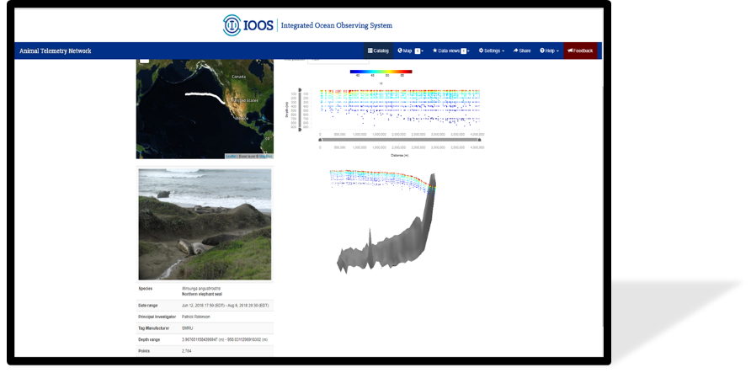   
Axiom is the data management and technology contractor for the ATN DAC, which is generally charged with receiving, handling, and distributing diverse data types from archival, satellite, and acoustic tag platforms that originate from a variety of individual Federal and non‐Federal marine animal telemetry programs.

Among the reasons that Axiom was chosen to implement the ATN operational DAC is that they currently are responsible for the data management activities of three of the IOOS Regional Associations: AOOS, CeNCOOS and SECOORA. While serving in that role, Axiom and those three Regional Associations have earned the distinction of being certified as a Regional Information Coordination Entity (RICE) under the authority of the Integrated Coastal and Ocean Observation System Act of 2009 (ICOOS Act). This means that they are certified by NOAA as meeting federal standards for data gathering and management. Actually all 11 IOOS Regions are RICE certified which, In simple terms, this means that ocean, coastal, and Great Lakes data and information from these non-federal System partners can now be used with the same confidence and assurances as federal data.

This ATN DAC project is being implemented by Axiom in four distinct phases. Phase 1 (Transition) was a discrete phase in which the existing data, capabilities, and functions were migrated from their previous location at Hopkins Marine Station to the Axiom data system. In Phase 2 (Prototype), the data ingestion workflow to the ATN DAC has been prototyped and enhanced using Axiom’s existing infrastructure producing specific Standard Operating Protocols (SOPs) for ATN data handling. The ATN DAC is currently being operationalized in Phase 3 (Operationalize) to iteratively ingest, curate, and archive animal telemetry datasets as they become available. Data will be stored in a secure, dedicated operational environment, called the ATN Research Workspace (https://researchworkspace.com). This task will also involve curation of the original data into a logical and efficient structure and expanding appropriate metadata documentation to fit the new structure. Curated datasets will be archived via semi-automated pathways in the Research Workspace to NOAA/NCEI for the long-term data preservation and stewardship of all animal telemetry data in the ATN DAC. Using feedback and experience from the prior phases, the ATN DAC will be enhanced in Phase 4 (Enhance), to improve the system’s performance and integrate new functionalities, as identified by the IOOS PO, the ATN NC, and other ATN DAC users.

Phase 3 is scheduled to be completed in May/June 2019. The ATN DAC public facing Data Portal will go live on May 1, 2019.

**ATN DAC Data Coordinator Hired**The ATN is pleased to announce the selection of Dr. Megan McKinzie for the NMFS/IOOS funded position of ATN Data Assembly Center (DAC) Data Coordinator. Megan joins us with a significant amount of experience in the marine animal telemetry community and she earned her Master’s Degree from Chris Lowe’s CSU Long Beach Shark Lab and more recently her PhD. from the School of Fisheries, Aquaculture and Aquatic Sciences at Auburn Univ. Megan arrived on the job March 11, 2019 and will work out of the CeNCOOS Regional Association Office at MBARI. She acts as the primary interface between the ATN DAC operated by Axiom Data Science and the U.S. satellite and acoustic marine animal telemetry community.

**Regional Acoustic Data Nodes**Regional data nodes are essential components of the distributed ATN data collection and management system. The ATN has established partnerships with the Ocean Tracking Network (OTN), the IOOS Regions and multiple regional organizations to help implement two regional “acoustic data nodes,” one in MARACOOS, called MATOS, and the other in SECOORA, called the FACT node. These nodes facilitate regional acoustic telemetry data aggregation, exchange and sharing, plus streamlined ‘orphan’ tag identifications. Both of the nodes will submit acoustic detection data from their regions to the DAC via their ERDDAP servers. While these tools will significantly increase the capabilities of the regional networks, each of them does require a data manager to make it all work effectively. Providing support for these data managers is consistent with the ATN objectives **(see Section III below, Data Wranglers)**. Additionally, the nodes are OTN compliant and thus also submit data to the Canadian OTN database. The ATN will continue to work with the OTN and partners in other IOOS regions to assist with strengthening these nodes and implementing others as needed.

III. Funding High Priority Regional Baseline Animal Telemetry Observations

**ATN Workshops** In a 16 month period during Phase II we have convened 6 Workshops covering a total of 9 U.S. IOOS Regions: MARACOOS, SECOORA/ CARICOOS, AOOS, GCOOS, PacIOOS and NANOOS/CeNCOOS/SCCOOS. We will convene workshops in the two remaining regions, NERACOOS and GLOS, in the spring and late fall of 2019. The complete reports for two of the workshops are included with this document and the others are in preparation. We have also begun the important process of distilling and combining the conclusions reached from our workshops into actionable items the ATN will seek to implement.   
One major outcome of our West Coast Workshop in November 2018 is that it has spawned an emerging *California Current Large Marine Ecosystem (CCLME) Biological Observation Group*. Inspired by the Workshop, the was created to maintain the momentum generated at the Workshop towards defining the requirements for a sustained West Coast Biological Observing System including the key scientific questions that need answering and identifying what is the baseline for measuring biological change. The group, currently chaired by the ATN Network Coordinator, includes 13 leading US West Coast biological scientists who are drafting their Terms of Reference which will frame some initial vision points for a collaborative biological observation network which will complement existing capabilities

The objectives of our workshops include:

• *Identify and prioritize regional telemetry research and potential keystone monitoring / observational needs*

*• Review the existing global telemetry observing assets and scientific capabilities,*

*• Document existing examples of stakeholder use of telemetry data*

*• Identify data management challenges, and showcase regional capabilities and tools with global linkages for data management, sharing and collaboration. Consider needs common to other regions, and discuss strategies for applied, collaborative research across geographies and disciplines*

**ATN Funding of Priority Telemetry Infrastructure/Assets**An additional top priority identified in the ATN Implementation Plan for Phase II, specifically in the CY 2018/CY 2019 timeframe, is for the ATN to begin, where needed, supporting the sustained operations of the existing United States tagging capability and receiver arrays that have been deployed during the past 15 years. ***To that end, the information gathered at the Workshops and other community-based activities, combined with SG guidance and funding support from BOEM, ONR and NOAA, has been used help identify, prioritize and fund infrastructure/assets that need to be supported in order to successfully sustain effective regional marine animal telemetry operations.*** The ATN has successfully implemented five new projects in CY 2018 aimed at strengthening the existing U.S. marine animal telemetry observation and data management infrastructure. These projects are identified and briefly described below.

* ***Two Data Wranglers/Managers: FACT and ACT Acoustic Networks*** With partnerships among SECOORA, the Florida Fish and Wildlife Research Institute (FWRI), Axiom Data Sciences, OTN, MARACOOS, the NOAA Chesapeake Bay Office, the Atlantic States Marine Fisheries Commission and RPS/ASA and support from the ATN, acoustic telemetry data Nodes are now operational for both the ACT and FACT community-based acoustic telemetry networks. Each of these Nodes are now being populated with acoustic datasets from their regions. For the Nodes to be effective however, they each must have a dedicated Data Manager/Data Diplomat that is a trusted interface with their communities who will recruit PIs to submit their data, will encourage data sharing and will insure that the data is properly managed. The ATN is now funding these two Data Manager positions, one for FACT (Joy Young: Florida Wildlife Research Institute through SECOORA) and the other for ACT (Kimberly Richie: Smithsonian Institution through MARACOOS).Due to the delayed timing for executing these funds, the positions have been funded for only six months so far. We will provide a report on their activities by mid-2019.
* ***High priority Georgia Coastal Receiver Array off St. Simon’s Sound***Theresearch of many groups along the US Atlantic coast, including the Coastal Array of Moored Acoustic Receivers Research at Cape Canaveral (supported by BOEM, NASA, and US Navy), have benefited greatly for years by coastal receiver lines maintained by Georgia DNR and South Carolina DNR. In particular, this Georgia Coastal Receiver Array off St. Simons Sound has recorded data from over 41 unique species, this includes more than 670 individual animals. Included in this number are 179 Atlantic Sturgeon, 13 loggerhead sea turtles, 15 Kemp’s Ridley sea turtles, 58 Tripletail, 10 Red Drum, 28 tiger sharks, and 40 white sharks. These data are shared with over 46 different research groups from 10 different state, federal, and non-governmental organizations. This collaboration has provided groundbreaking data on the movements of marine animals. Additionally, data from the operation of this receiver array has led to the discovery of a shared migratory group of Tripletail (highly sought-after recreational species) between Georgia and Florida. This discovery has led to the coordination of management between the two states to prevent the overfishing of the species. ***Currently data from this array are being used as part of the South Atlantic Fishery Management Council (SAFMC) Southeast Data, Assessment, and Review (SEDAR) Atlantic Cobia Stock Identification Workshop. The results from this workshop will be used to provide stock delineation guidance to the SAFMC SEDAR 2019 Atlantic Cobia Stock Assessment.***

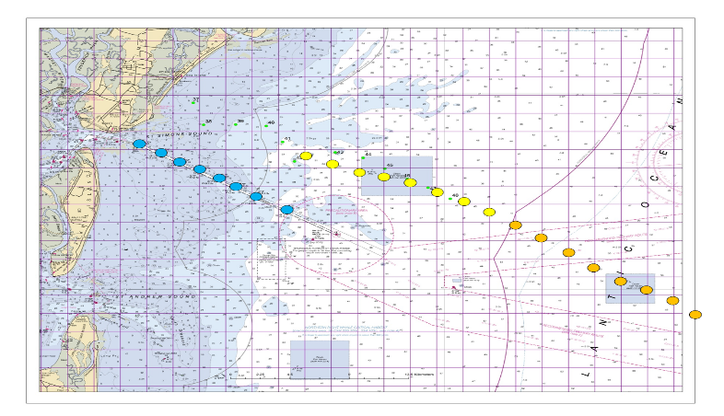This Coastal Receiver Array is the only one of its kind in Georgia. It has been in continuous operation since 2014, thanks in large part to the partnership with the ATN. The continuous operation and strategic location have proven valuable for many studies that track animal movements between overwintering habitat in Florida and critical habitats to the north. Being that the array has changed very little since it was established, researchers are able to examine repeat migrations of animals through the region across multiple years. The array fills a major gap between similar arrays in South Carolina and Florida. Data from the array are vital to several recently funded regional studies. This includes an ongoing tagging study on the migrations of Atlantic Cobia by researchers in Virginia, North Carolina, South Carolina, Georgia, and Florida. Without Georgia’s array there would be a significant and detrimental gap in array coverage in the Southeast. The 2018 partnership between the Georgia Department of Natural Resources and the ATN ensures that researchers throughout the Southeast, the Atlantic Coast, and internationally will continue to receive valuable data from the array for at least another year.

* ***Argos Satellite Data Fees Payment Program for ATN Researchers***The satellite data collection and location service of Argos is an essential element of the U.S. national animal telemetry observations infrastructure. Consequently, providing sustained, robust Argos service to the U.S. marine animal tracking researchers within the ATN will help to insure the stability, continuity and sustainability of the high priority, long-term satellite tagging efforts of the ATN. The ATN Argos Fees Program is multi-year program funded by ONR, which will pay for the cost of Argos satellite tracking services for marine animal telemetry researchers who agree to display their animal tracks in real time on the ATN DAC website, as well as submit their data to the ATN DAC. Data in the ATN DAC are protected from public download for the period specified by sponsoring agency and in accordance with the ATN Data Sharing Guidelines. This program currently supports 14 programs with 234 tags. We have reached out to BOEM funded researchers to recruit their participation.
* ***Develop the Next Generation of Animal Movement Analysis Tools***This is development work by Dr. Ian Joneson that is funded by ONR. State-space models and hidden Markov models have revolutionized the analysis of animal tracking data, leading to a robust capability for the inference of unobserved movement behaviors from location data obtained via animal-attached telemetry devices. Of the two tools, state-space models are the preferred choice when dealing with animal tracking data that is highly prone to measurement error, e.g. light-level geolocation data and Argos satellite data. Bayesian Markov Chain Monte Carlo methods are a widely-used, computer-intensive approach for fitting complex state-space models to data but they can be extremely slow to implement. This slow computation time prevents the development and application of more advanced models that can infer realistic and complex animal movement processes. Despite this hindrance, it has become clear that such models now are essential both for handling the high-volume, complex data collected by animal-attached devices and for understanding how animals may respond to current and future environmental change. This project aims to develop the next generation of animal movement analysis tools by building a powerful, lightning-fast and easily used toolbox of state-space models for multiple types of animal tracking data. These tools will be implemented within our ATN DAC and thus be available to all researchers who set up their password protected accounts within the DAC.

APPENDIX A

ATN FY-18 Funding Structure

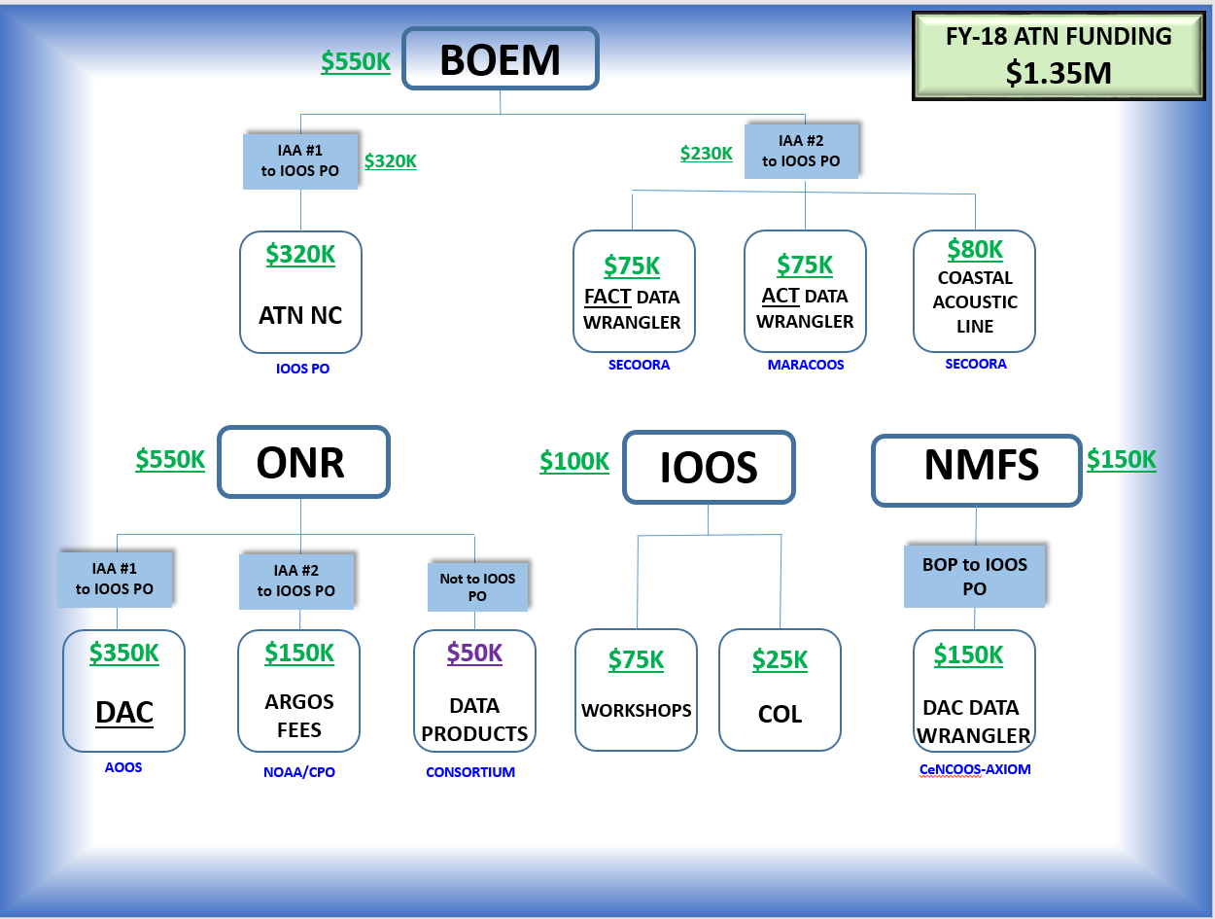

APPENDIX B

The SECOORA-CARICOOS and the AOOS ATN Workshop reports are completed and will be posted on the IOOS.NOAA.GOV website as soon as the site is finished be upgraded. The ATN site is currently undergoing a significant reconfiguration. The covers for the two reports are illustrated below.

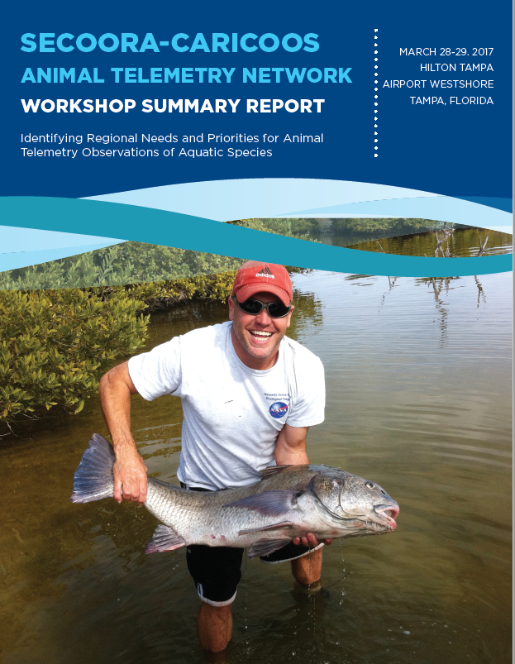

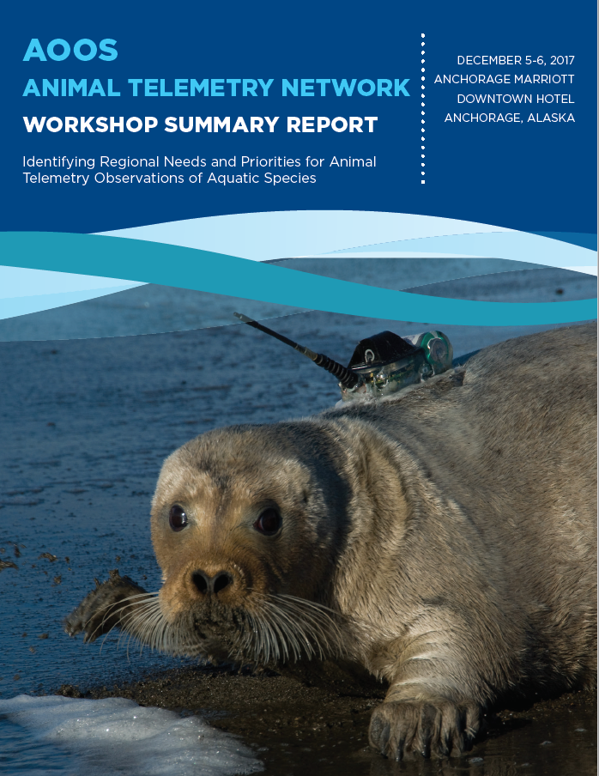

APPENDIX C

ATN Coordinator Travel Summary



APPENDIX D

“From the ATN Wheelhouse” Monthly Reports



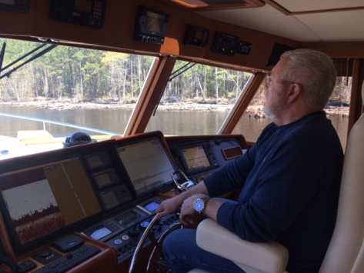

**No. 11  
September 30, 2017  
*Bill Woodward  
ATN Technical Coordinator***

**Our hearts and best wishes go out to all our friends affected by the devastating hurricanes**

* **The ATN Coordinator’s Annual Report has been submitted to BOEM. It will be posted on the ATN section of the IOOS website.**
* **The BOEM/Navy Canaveral Shoals turtle live tracks are now being displayed on the DAC website !**
* **Kevin Schabow (NMFS/CBO), Peter Moore (MARACOOS), Matt Ogburn (Smithsonian – SERC) and Bill joined in a call to meet Alicia Morandi, the new person at RPS/ASA responsible for our new MATOS acoustic data aggregation tool. The web-based tool Is is looking very good and some exciting news is that the MATOS scientific team is adopting the “VEMBU” database tool for acoustic telemetry metadata that Joy Young, Jon Pye and others have developed for the FACT network. Great collaborative efforts!**
* **Bill attended the ‘Cetacean Tag Development and Tagging Best Practices Workshop’ at the NOAA campus in Silver Spring sponsored by ONR (M. Weise), NMFS (T. Rowles) and the International Whaling Commission (G. Donovan). Workshop purpose was to review and evaluate progress in tag design and attachment since their previous ONR sponsored Workshop in 2009 to identify and collectively advance designs that maximize tag attachment duration while minimizing risks to animals. A set of specific recommendations that built on those from the 2009 meeting was developed, some of which called for ATN participation.**
* **Bill and Mike attended the 6th International Biologging Symposium in Konstanz, Germany. Led by Martin Wikelski of the Max Planck Institute for Ornithology, and convened by the newly formed International Biologging Society, the Symposium attracted 420 attendees who came together to hear 85 speakers describe their biologging science activities, to participate in workshops on 6 separate topics including Data Standards and Interoperability in the Biologging World and to interact with a dozen telemetry manufacturers. We presented an ATN poster and had an opportunity to meet with a large number of the attendees on a wide range of ATN related topics including joining a multi-partner fellowship project with ONR support that includes MacQuarie Univ. (Australia) - IMOS/ATF, OTN, VEMCO and others, to support the development of an easily used animal movement analysis toolbox for the animal tracking community.**
* **The Duke Univ. Marine Geospatial Ecology Lab (MGEL) has invited Bill to be a member of the Strategic Advisory Panel for their Migratory Connectivity in the Ocean (MiCO) system. MGEL is leading a consortium to develop MiCO as part of the larger Global Ocean Biodiversity Initiative (GOBI) from the German International Climate Initiative. Among other things, MiCO will convey information on animal connectivity among aggregation of life cycle areas - ‘nodes’, and via travel paths – ‘corridors’ between nodes. This will provide a vital link between the ATN and the stakeholder community.**
* **Mike and Bill met by phone with Hendrik Nollens, Senior Staff Veterinarian at Sea World, to discuss a possible partnership through which the ATN would assist in the management and distribution of Sea World marine animal tags for tracking rehabilitated animals released back into the wild.**

**GLOSSARY: (**For those having difficulty navigating through the DC alphabet soup speak**)**

**NMFS/CBO:** National Marine Fisheries Service/Chesapeake Bay Office  
**Smithsonian- SERC:** Smithsonian Environmental Research Center

**RPS/ASA:**  RPS Group/Applied Science Associates

**MATOS:** Mid-Atlantic Acoustic Telemetry Observation System

**“VEMBU”:** VEMco Biotelemetry User

**FACT:** Florida Atlantic Cooperative Telemetry

**IMOS/ATF:** Integrated Marine Observing System/Animal Tracking Facility

**OTN:** Ocean Tracking Network (Canada)

**VEMCO:**  Canadian company supplying acoustic fish tracking and monitoring equipment



**No. 12  
October 31, 2017  
*Bill Woodward  
ATN Technical Coordinator***



**From the ATN Wheelhouse……**

* **Live tracks from Robin Baird’s (Cascadia Research Collective) 5 Cuviers Beaked Whales and 1 Pilot Whale, plus 2 Melon-Headed Whales from earlier this year are now being displayed on the ATN DAC site: oceanview.pfeg.noaa.gov/ATN/**
* **Tracks from Kim Holland’s (U. of Hawaii) 5 tigers sharks from 2017 around the Hawaiian Islands are also being displayed on the ATN DAC site.**
* **Live tracks now on the ATN DAC site from Bowhead Whales being tracked by Lori Quakenbush (Alaska Dept. of Fish and Game) and Jonas Teilmann (AARHUS U.- Denmark) around Baffin Bay/Baffin Island and the Beaufort Sea.**
* **The ATN has connected with Stephen Zepecki, the NOAA Educational Outreach Coordinator for NOAA’s “Science on a Sphere” (SOS) for initial discussions on displaying marine animal telemetry tracks on the SOS. This will be a terrific outreach activity for the ATN. We’re now working on the technical steps to format and make the data accessible.**
* **Bill is a member of the OTN International Data Management Committee (IDMC) and participated in and provided an ATN overview at their annual meeting, Oct. 16-17 which overlapped with the 2017 OTN Symposium in Halifax. The IDMC reports to the OTN Executive Director, Fred Whoriskey, and provides oversight to ensure the OTN data management model is implemented and operated reliably and efficiently.**
* **The announcement and draft agenda for the AOOS-ATN Workshop, December 5-6 in Anchorage, are available at:** [**https://tinyurl.com/ybhnegvv**](https://tinyurl.com/ybhnegvv)
* **Bill and Mike have met with Rob Harcourt & Ian Jonsen (Macquarie Univ. - Sydney) several times to define the details of ATN participation in a new international, multi-collaborator Fellowship supporting Ian to create an updated animal movement analysis toolbox that will enable practitioners to link animal tracks with environmental and human activity datasets in a simpler, more robust manner.**

**GLOSSARY: (**For those having difficulty navigating through the DC alphabet soup speak**)**

**OTN:** Ocean Tracking Network (Canada)



**No. 13  
November 30, 2017  
*Bill Woodward  
ATN Technical Coordinator***



**From the ATN Wheelhouse……**

* **Our second ATN Steering Group (SG) Meeting was held on November 8. It was a four hour remote access meeting and all but 4 SG members were in attendance. Excellent support as always was provided by Kruti Desai and Nick Rome from COL. The meeting agenda included an update of ATN activities since the last meeting in early June, informational inputs from the agencies that are providing funds for the ATN, a review of the Actions from the June meeting and an in-depth discussion of new topics including examples of the baseline observations and infrastructure the ATN is likely to begin funding in FY-18 and the process for selecting and prioritizing them. A meeting report is in preparation and the next SG meeting is targeted for mid-March 2018.**
* **Sean Hayes and Bill had a very productive meeting with Ron Smolowitz and his team at the Coonamessett Farm Foundation (CFF) and with Heather Haas from NMFS/NEFSC at the CFF facility in Falmouth, MA to bring them up to speed on the status of the ATN and to seek their participation in the ATN program. They have agreed to submit 43,000 ocean profiles to the ATN DAC that have been collected by satellite tagged sea turtles in the Atlantic off the U.S. east coast.**
* **Bill was invited to give a talk, “The U.S. Animal Telemetry Network and the Importance of Argos,” at the June 2-3 Argos Manufacturer’s Seminar at the Woods Hole Oceanographic Institution (WHOI). Nearly 40 attendees came together at the meeting to hear members of the CLS Group update the Argos manufacturing community on the optimistic future of Argos, demonstrate how the Argos Chip (ASIC) can be easily integrated into new and existing platforms, and strengthen their relationships with Argos tag manufacturers. Argos continuity is essential for ATN.**
* **Bill also had a chance to visit with several members of the WHOI animal telemetry science community (Mark Baumgartner, Aran Mooney, Kara Dodge) to learn more about their work and to update them on the goals and activities of the ATN.**
* **The ATN has committed to organizing a session on ATN/MATOS/Animal Telemetry Data at a NMFS sponsored sturgeon workshop in Gloucester, May 2018. The plan is for the session to include a discussion of the ATN goals and activities and describe the role of MATOS (Mid-Atlantic Telemetry Observing System) in the mid-Atlantic ACT (Atlantic Cooperative Telemetry) Network. ACT is a regional community-based effort created to facilitate data-sharing among researchers utilizing acoustic telemetry.**

**From the ATN Wheelhouse……**



**No. 14  
December 31, 2017  
*Bill Woodward  
ATN Technical Coordinator***



* **Highlight of the month was our AOOS-ATN Workshop in Anchorage. Thanks to the tireless efforts of Molly, Carol and Holly, we had twenty-four excellent speakers from the Resource Management, Private, Community/Tribal and Research Sectors in the AOOS Region join us and bring the participants up to speed on their regional marine animal telemetry observational needs and priorities in Alaska, the specific applications for them and their perspectives on the value of a commitment to long-term sustained telemetry observations. Common themes and conclusions for each of the objectives will be documented in the Workshop report targeted for early April.**
* **Next up will be the GCOOS-ATN Workshop, January 23-24 in New Orleans. Supported by a carefully selected planning committee, Chris, Barb and Jen have been working hard to make this possible. We have commitments from nearly all the speakers and will finalize the list within a week. Information and Registration at:** http://gcoos.org
* **Planning is underway with Fiona Langenberger and Kim Holland for our PACIOOS-ATN Workshop in Honolulu – last week in April is the target time**
* **A project has been initiated to transition our ATN DAC from its current research/developmental phase at the Stanford Hopkins Marine Station research environment to a location and environment which is dedicated to operational execution/support and customer service. The plan will be executed cooperatively with Hopkins over the next 6-12 months. Regular updates will follow.**
* **Discussions this month with Woody T. and Gabrielle to crystallize ideas for uniting our ATN and MBON efforts into a sustained biological observing capability in IOOS. Among the ideas discussed was to consider rallying agency support for a topic for the FY-19 NOPP BAA.   Initial topic idea: Demonstrate how bringing the ATN animal movement obs and the MBON genetics (and other) capabilities together with remotely sensed obs under a "SEASCAPES" umbrella could be  a valuable way to illustrate the importance of these bio. observing programs.**
* **The Argos satellite data collection and location system is an essential element of our U.S. national animal telemetry infrastructure. Recently, Bill had a chance to brief BOEM and NASA on the current status of the Argos satellite system and on actions underway by the French Space Agency (CNES) to build a prototype miniaturized Argos receiver & transmitter for deployment on a constellation of cubesat satellites. The informational briefing was aimed at creating a direct collaborative linkage between CNES and a joint project underway by BOEM and NASA to ‘develop and demonstrate an alternative satellite tracking capability by leveraging NASA’s cubesat partnerships.’**
* **Providing Argos service funding for priority ATN satellite telemetry activities is a candidate for ATN Phase II support. Bill is working with Eric Locklear, the Argos Joint Tariff Agreement Chairman as well as the financial officer for NOAA’s Climate Program Office, to identify funding pathways that would facilitate applying ATN funds to pay Argos service fees for ATN PI’s. Specific mechanisms will be defined in January.**

**GLOSSARY:** (For those having difficulty navigating through the DC alphabet soup speak)

**MBON:** Marine Biodiversity Observation Network  
 **NOPP BAA:** National Ocean Partnership Program Broad Agency Announcement  
 **Cubesat:** A class of miniaturized, typically research-based satellites



**No. 15  
January 31, 2018  
*Bill Woodward  
ATN Technical Coordinator***

**From the ATN Wheelhouse……**

* **We hosted our 4th ATN Workshop this month with GCOOS in NOLA!! Chris, Barb and Jen did a tremendous job in bringing together 50+ outstanding participants from the commercial, resource management and research sectors to exchange thoughts, requirements and conclusions regarding marine animal telemetry activities in the Gulf of Mexico Region. Workshop report will follow in a few months. Next up will be the PACIOOS-ATN Workshop, April 23-24 in Honolulu.**
* **Mike, Bill and Jon Pye from the Canadian Ocean Tracking Network serving as an official ONR peer reviewer, conducted a two-day technical review of our ATN DAC at the Stanford U. Hopkins Marine Station in Monterey. This review formally kicked off our efforts to transition our DAC from its current research/developmental implementation at Hopkins to a location dedicated to operational execution/support and customer service. Axiom Data Science was selected as the location to which the DAC will be transitioned.**
* **Bill met with the Financial Dir. Of NOAA’s Climate Program Office to define streamlined funding pathways and mechanisms for the ATN to pay for the Argos satellite telemetry costs for Principal Investigators designated to be members of the ATN. This is being considered by the ATN as one of the contributions to supporting Animal Telemetry baseline observations. Work is now underway to define and implement the specific administrative tasks required to put this into practice.**
* **Kevin Schabow, Acting Dep. Dir. Of the NMFS Chesapeake Bay Office, and Bill met to identify mechanisms for integrating the MATOS tool into the mid-Atlantic ACT acoustic telemetry Network and for providing sustained support for the ACT-MATOS community. Conference call with MARACOOS is scheduled for early February.**
* **Bill gave ATN update presentation at the NOPP Biodiversity Ad Hoc Working Group meeting this month.**

**GLOSSARY:** (For those having difficulty navigating through the DC alphabet soup speak)

**MATOS:** Mid-Atlantic Acoustic Telemetry Observation System



**No. 16  
February 28, 2018  
*Bill Woodward  
ATN Technical Coordinator***

**From the ATN Wheelhouse……**

* **GLATOS graciously welcomed the ATN this month to their 2018 Annual Coordination Meeting which included participation of their 100+ members with 48 individual presentations, including our ATN update talk, showcasing the breadth of their outsanding acoustic telemetry efforts in the Great Lakes Region. While there, Bill had a chance to speak at length with Kelli, Chuck Krueger, Chris Holbrook and Nancy Nate to chart a course for closer integration of GLATOS within the ATN with specific ideas on fostering closer collaboration and cross pollination among all U.S. acoustic networks, e.g. ACT, FACT, iTAG……**
* **Lots of time this month developing the statement of work and deliverables for the transition and implementation of an operational ATN DAC by Axiom. Hopkins is scheduled to deliver the remaining information by March 7 needed to initiate a smooth implementation of transitioned capabilities.**
* **Fiona, Kim and Bill have been aggressively soliciting speakers and attendees for our PACIOOS-ATN Workshop, April 23-24 in Honolulu. The agenda is shaping up well with 15 speakers aleady committed. We’ve had limited success so far recruiting speakers from the Commercial Sector so that sector is currently our highest recruiting priority.**
* **Additional conversations with MARACOOS (Gerhard), NMFS and the Smithsonian have led to a March 22 meeting at the U. of Delaware with the ACT Network leadership to seek their support for housing and operating the MATOS acoustic telemetry web-based tool within the MARACOOS infrastructure, including a dedicated Data Wrangler position for ACT.**
* **The ATN has been invited by Rob Harcourt, Macquarie U., to be a co-author on an abstract to Ocean Obs ’19: “*Animal Telemetry: An Essential Sensor in Ocean Observing Systems.”* Mike Weise, Kim Holland and Bill will be co-authors with about a dozen other Canadian, U.S. and Australian colleagues.**
* **Abby Benson, USGS/OBIS, invited the ATN to be a co-author on an abstract to a workshop on *“*Standards for Interoperability for Bio-logging Data*”* that is part of the joint SPNHC - TDWG Conference in August in New Zealand. The abstract is titled: “*Outcomes of the IODE/OBIS-Event-Data Workshop on Animal Tagging.”* Bill will be a co-author along with multiple colleagues from Canada, Europe and Australia.**
* **Daniel Dunn, Duke Univ.Marine Geospatial Ecology Lab., has invited Bill to be a co-author with two dozen other U.S. and European contributors on a Policy Perspective piece to ‘Conservation Letters’ entitled: *“Global ocean governance requires actionable knowledge on migratory connectivity.”***
* **Dawn Wright, Chief Scientist at Esri, has invited Mike Weise, Sean Hayes and Bill to contribute material for a new Esri Press book (print and digital) to be published in 2019. The tentative book title is *“GIS for Science: How Professionals and Citizens Bring Clarity, Rigor, and Storytelling to Their Scientific Research with ArcGIS.”*  A likely focus for us could be ‘Animals as Oceanographers.’**

**GLOSSARY:**

**GLATOS:** Great Lakes Acoustic Telemetry Observing System

**MATOS:** Mid-Atlantic Acoustic Telemetry Observation System

**OBIS:** Ocean Biogeographic Information System

**SPNHC:** Society for the Preservation of Natural History Collections

**TDWG:** Taxonomic Data Bases Working Group (aka Biodiversity Information Standards)

**Esri:** Environmental Systems Research Institute – int’l supplier of GIS software



**No. 17  
March 30, 2018  
*Bill Woodward  
ATN Technical Coordinator***



**From the ATN Wheelhouse……**

* **All systems are go for our PACIOOS-ATN Workshop, April 23-24 in Honolulu. See:**

[**http://www.pacioos.hawaii.edu/pacioos-updates/animal-telemetry-network-workshop/**](http://www.pacioos.hawaii.edu/pacioos-updates/animal-telemetry-network-workshop/)

* **ATN DAC Transition - Very constructive virtual meeting on March 20 between the Axiom and Hopkins teams that addressed higher-level issues as well as began answering specific technical questions about the code and data that Hopkins has transitioned to Axiom; the meeting fostered multiple positive follow up calls and continuing useful technical e-mail exchanges between the teams.**
* **Very productive meeting at U. of Del. with MARACOOS, Delaware State U., NMFS/CBO and Smithsonian at which agreement was reached on how the MATOS tool could be used through a regional acoustic node Data Wrangler to support the data needs of the ACT telemetry network.**
* **NANOOS, CeNCOOS and SCCOOS have agreed to begin planning for a joint west-coast ATN workshop in early Fall 2018. We will partner with MBON and our Canadian OTN friends. We have also agreed with NERACOOS to hold an ATN Workshop in early 2019 and to similarly partner with MBON and OTN.**
* **Justin Manley (Just Innovation, LLC) met with Bill, to get an update on the implementation of the ATN and to explore possible cooperative entrepeneurial efforts on telemetry tag technology.**
* **Bill provided the ATN update at the March 26 IOOC Mtg.**
* **Lots of time this month devoted to prep for the upcoming Steering Group Mtg., SG-3, on April 19. It will be a virtual meeting and everyone is welcome. If you are interested in joining please contact me. The agenda will be available the first week in April.**
* **Mike Weise and Bill have been working with Melinda Holland, CEO of Wildlife Computers, Inc. (WC), one of the primary marine animal satellite tag providers, to help cooperatively define the data pathways for oceanographic Depth-T,S,Do profiles from their tags to Argos to WC to the DAC and insertion onto the WMO Global Telecommunications System (GTS); we are also connecting WC with the oceanographers that are supporting the marine tagging community so they can help WC to optimize the hardware design and sampling features of their tags.**

**GLOSSARY:**

**CBO:** Chesapeake Bay Office

**MATOS:** Mid-Atlantic Acoustic Telemetry Observation System

**ACT:** Atlantic Cooperative Telemetry

**IOOC:** Integrated Ocean Observation Committee



**No. 18  
May 1, 2018  
*Bill Woodward  
ATN Technical Coordinator***



**From the ATN Wheelhouse……**

* **Our PACIOOS ATN Workshop on the U. of Hawaii campus in Honolulu April 23-24, 2018 was an enormous success due to the support from Melissa Iwamoto the Executive Director of PACIOOS, from Fiona Langenberger, PACIOOS Communications Director, who flawlessly led the organization, management and implementation of the meeting and from the contributions of the outstanding 55 speakers/participants from the Pacific Islands Region, including Dr. Kim Holland, Hawaii Institute for Marine Biology and Dr. Brian Taylor, Dean of the School of Ocean and Earth Science and Technology (SOEST) at the U. of Hawaii and Chair of the PacIOOS Governing Council. Animal telemetry stakeholder observing needs and ongoing programs were reported on from as far away as New Caledonia, Pohnpei and Guam with a specific concentration on observation needs and the large amount of telemetry activities in and around the Hawaiian Islands. Workshop participants collectively acknowledged the value that the ATN DAC can bring to address the challenges of the broad animal telemetry efforts in the Region. They expressed a strong willingness to work directly with the ATN especially to take full advantage of the data management, aggregation, access, sharing and archiving capabilities of the DAC.**
* **Bill gave two ATN talks in DC the week of April 23: At the NASA Biodiversity and Ecological Forecasting Team Meeting and at the MBON All-Hands Meeting.**
* **The third meeting of the ATN Steering Group (SG) was convened on April 19, 2018. It was a remote, webinar meeting with 8 of the 9 federal agency members in attendance and 3 of the 4 non-federal members. The meeting focused on, i) reviewing the progress of the transition of the ATN Data Assembly Center to an operational environment, ii) reviewing the proposal developed by an SG task team for an open and fair competitive mechanism to identify and fund priority telemetry baseline observations and, iii) reviewing four proposed candidate projects. Meeting minutes will be available on the IOOS website soon.**
* **Our ATN DAC Transition to Axiom continues to go smoothly with a target of July 2018 for the new DAC to be functionally operational.**
* **Kyle Wilcox (Axiom) and Abby Benson (OBIS-USA) represented the ATN at the April 23-26, 2018 IODE/OBIS-EVENT-DATA Workshop on Animal Tagging and Tracking (ATT) in Oostend, Belgium. The Workshop focused on identification and description of existing ATT data products and applications and the development and testing of specific products building on the OBIS-ENV-DATA standard.**
* **We are exploring the possibility of NDBC implementing the capability to accept ocean profiles collected by animal-borne telemetry tags, converting them to BUFR data format and inserting them in real-time onto the GTS.**
* **Planning is underway with NANOOS, CeNCOOS and SCOOS for our joint west-coast ATN workshop in partnership with MBON and our Canadian OTN friends. Location will be Santa Cruz, CA on November 7-9, 2018.**

**GLOSSARY:**

**IODE:** International Oceanographic Data and Information Exchange

**OBIS:** Ocean Biogeographic Information System

**MBON:** Marine Biodiversity Observation Network

**NDBC:** National Data Buoy Center

**GTS:** Global Telecommunication System (of the World Meteorological Organization)

**OTN:** Ocean Tracking Network



**No. 19  
June 1, 2018  
*Bill Woodward  
ATN Technical Coordinator***

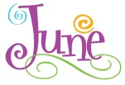

**From the ATN Wheelhouse……**

* **West Coast ATN-MBON-OTN Workshop planning fully underway with bi-weekly calls. Venue will be the Hotel Paradox in Santa Cruz, Nov. 7-9, 2018. Save the Date notice going out soon.**
* **ATN Steering Group Voting Members met on May 23rd and approved four telemetry projects for FY-18 funding support subject to availability of funds. Formal notices will be sent to the awardees the week of June 11.**
* **During our ATN DAC transition process, Machine-to-Machine data connections are being established between Axiom and satellite telemetry tag manufacturers for our new DAC – Wildlife Computers, Argos/Woods Hole Group, Sea Mammal Research Unit (SMRU). This will give the DAC direct access to the telemetry data enabling real-time tracks to be automatically ingested into the DAC and displayed on the website with the PI’s permission. Selected community members are beginning to test drive the process.**
* **NMFS funding for an ATN DAC Data Wrangler has been approved. Position Description is being prepared.**
* **We have been able to secure technical writing assistance to help prepare the reports from the ATN Workshops. All reports for completed Workshops should be finished by early Fall this year.**
* **Becca Lewison, Associate Professor and Dir. Of the Institute for Ecological Monitoring and Management at San Diego State Univ., is including the ATN in an A.8 NASA Roses Proposal that leverages telemetry data to develop dynamic ocean mgmt tools and products for U.S. fisheries.**
* **Bill and Rob Bochenek presented the ATN/DAC at the DMAC mtg in late may in Silver Spring.**
* **The ATN has received verbal agreement from NDBC to develop the capability for inserting ocean profiles from animal-borne tags onto the GTS. First step will be to create a new BUFR template for the profiles from the marine animals which can also be used for profiles from gliders. We are creating a joint google doc to describe the effort.**

**GLOSSARY:**

**MBON:** Marine Biodiversity Observation Network

**OTN:** Ocean Tracking Network (Canada)

**ROSES:** Research Opportunities in Space and Earth Science

**NDBC:** National Data Buoy Center

**GTS:** Global Telecommunication System (of the World Meteorological Organization)

**BUFR:** Binary Universal Form for the Representation (of meteorological data)



**No. 20  
July 1, 2018  
*Bill Woodward  
ATN Technical Coordinator***

**From the ATN Wheelhouse……**

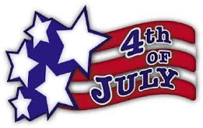

* **Notices of FY-18  ATN project funding have been sent to awardees. With BOEM and ONR support, the ATN has awarded $380K  for two regional Data Wranglers, the redeployment of a portion of a strategic Georgia DNR Coastal Acoustic Telemetry Receiver Array and a mechanism to fund Argos fees for ATN satellite tagging researchers.**
* **Save-the-Date notice for our West Coast ATN-MBON-OTN Workshop is being distributed – thanks Alex ! Reminder: November 7-9, 2018, Santa Cruz, CA.**
* **Axiom is moving along well on our Operational ATN DAC including the M2M links with Wildlife Computers and CLS America (Woods Hole Group); some initial data submission functionalities will be turned on at the end of this month.**
* **Preparations are underway for an ATN Workshop that will be convened at the American Fisheries Society 2018 Annual Meeting in late August in Atlantic City. ATN SG members Matt Ogburn-Smithsonian, Kristen Hart-USGS and Joy Young-Fla. Fish and Wildlife Conservation Commission will join Bill for a presentation and panel discussion of ATN and fisheries needs for telemetry data.**
* **A substantial amount of time has been spent the last few months working and re-working the Interagency Agreement documents language for FY-18 funding ($1.05M) transfers from BOEM and ONR to IOOS. A great deal of thanks to Debra, Dave and the whole RB&P IOOS Team for their exceptional help !**
* **Joy Young presented a demo of our DAC website at the recent FACT Network Meeting in Florida. Super job, thanks Joy!**
* **Eligibility criteria for ATN Researchers to have their Argos satellite fees paid by the U.S. Animal Telemetry Network (ATN) is being finalized. Payment mechanisms should be in place by the end of summer.**
* **Our plans for next month include a review and update of the content of the ATN pages on the IOOS.noaa.gov website.**

**GLOSSARY:**

**MBON:** Marine Biodiversity Observation Network

**OTN:** Ocean Tracking Network (Canada)

**FACT:** Florida Atlantic Cooperative Telemetry



**No. 21  
August 1, 2018  
*Bill Woodward  
ATN Technical Coordinator***

**From the ATN Wheelhouse……**



* **If you are interested in attending our West Coast ATN-MBON-OTN Biological Observations Workshop in Santa Cruz, Nov. 7-9, 2018 you can now register at** [**www.sccoos.org/2274-2/**](http://www.sccoos.org/2274-2/)**.**
* **We have begun on-boarding researchers who are ready to submit their data and metadata to the ATN DAC. The process is implemented using the Axiom Research Workspace platform that enables collaborative management of science projects. Please contact Bill for further information.**
* **The position description for our NMFS funded DAC Data Wrangler is nearly finalized and we are targeting late August to begin advertising it.**
* **Plan to join us at our upcoming ATN Workshop at the American Fisheries Society (AFS) Meeting in Atlantic City. The Workshop is scheduled for 11:00am-12:00 noon on Monday August 20 where ATN Steering Group members Matt Ogburn-Smithsonian, Joy Young – Fla. Fish & Wildlife Conservation Commission and Kristen Hart-USGS will join Bill for a presentation and panel discussion of the ATN and of fisheries needs for telemetry data.**
* **Our SECOORA-CARICOOS ATN Workshop Report has been completed and will be available for download in the next few days. The AOOS ATN Workshop Report is now in preparation and will be followed by the Reports from the GCOOS and PACIOOS Workshops.**
* **Our next ATN Steering Group meeting, SG-4, will be a remote meeting scheduled for Thursday August 23, 2018, 1-5PM EDT.**
* **We are pleased to report that the ATN has successfully secured continuing administrative support via a NOAA/IOOS grant award to the Consortium for Ocean Leadership (COL). Nick, Kruti and Callan will continue to provide assistance for our ATN SG Meetings as well as our Workshops, including report preparation.**
* **The ATN has had productive planning discussions recently with NMFS (Kevin Schabow) and Smithsonian (Matt Ogburn) to develop ideas for re-energizing the Atlantic Cooperative Telemetry (ACT) acoustic network and its research community with ATN assistance, as well as integrating the MATOS web-based tool into their network. We expect to review this further at our AFS Workshop on August 20.**

**GLOSSARY:**

**MBON:** Marine Biodiversity Observation Network

**MATOS:** Mid-Atlantic Observation System



**No. 22  
September 1, 2018  
*Bill Woodward  
ATN Technical Coordinator***

**From the ATN Wheelhouse……**



* **The ATN is recruiting for the position of ATN DAC Science Coordinator Position. Resumes will be accepted until September 21, 2018. Please visit:**

[**https://axiomdatascience.com/jobs/**](https://axiomdatascience.com/jobs/)

* **Registration is open for our ATN-MBON-OTN Biological Observations Workshop that will cover all three west coast IOOS Regions: NANOOS, CeNCOOS & SCCOOS. The Workshop is scheduled for November 7-9, 2018 and will be held in Santa Cruz, CA. Register at:** [**https://www.cencoos.org/about/events/2018/atn-mbon-otn-biological-observation-workshop**](https://www.cencoos.org/about/events/2018/atn-mbon-otn-biological-observation-workshop)
* **The fourth meeting of our ATN Steering Group, SG-4 was convened on Aug. 23rd. The virtual meeting focused on re-activating the DAC evaluation Task Teams, steps to take for advertising a call for ideas for FY-19 funding and preparation of our ATN DAC Data Policy.**
* **We successfully completed the preparation, approval and execution of the four Interagency Agreements that transfer the BOEM and ONR ATN funds to IOOS to support our ATN program activities (8 months of team effort !)**
* **We have begun on-boarding researchers who are ready to submit their data and metadata to the operational ATN DAC. The process is implemented using the Axiom Research Workspace platform that enables collaborative management of science projects. Please contact Bill for further information.**
* **Work has been initiated on a proposal led by Dr. Chris Simoniello from GCOOS to the NOAA RESTORE FFO 2019. The effort being proposed was triggered by our January 2018 GCOOS ATN Workshop in New Orleans and has 13 co-investigators and 9 Advisors, including the ATN, and is titled: "Coordinated Gulf of Mexico Animal Telemetry for Integrated Research and Management." Proposals to the FFO are due October 31st.**
* **At their request, Bill provided an overview briefing of the ATN to the NMFS Office of Protected Resources, Permitting Branch to fill them in on our ATN objectives, plans and status. The Permitting Team is enthusiastic about the ATN approach and goals and is considering including a requirement in the permit granting process that researchers must submit their tagging data to the ATN DAC.**
* **The draft Agenda for our 3-Region West Coast ATN-MBON-OTN Workshop has been prepared. After review, editing & approval by our Planning Committee the speaker invitations will go out hopefully no later than the second week in September.**
* **Bill provided the ATN update at the IOOC Meeting on August 13.**
* **We convened an ATN Workshop in Atlantic City on August 20th at the American Fisheries Society Annual Meeting. The Workshop was one of a day long set of discussion groups/meetings aimed at "Connecting Diverse Communities and Advancing Migratory Species Conservation through Animal Telemetry Studies in the Northwest Atlantic and Caribbean Waters. Bill and ATN SG Members Joy Young (FWC) and Matt Ogburn (SERC) provided an overview of the ATN to the participants followed by an interactive panel discussion with the participants.**
* **ATN will initiate the process for paying the Argos satellite fees for registered ATN researchers on or about October 1, 2018. The $150K funding has been transferred from ONR to IOOS to the NOAA Climate Program Office with whom a mechanism has been established to pay Argos fees invoiced from the Woods Hole Group (formerly CLS America). Researchers wiashing to register please contact Bill.**
* **Bill has been asked to be a member of the Scientific Steering Committee for a Fellowship Project awarded to Dr. Ian Joneson by Macquarie Univ.in Australia funded by a Consortium of partners including, among others, the ATN/ONR, the Canadian OTN and Vemco (acoustic tagging vendor). During the three year Fellowship Ian will apply innovative computational methods to create a new animal movement analysis toolbox to allow practitioners to link animal tracks with environmental and human activity datasets in a simple, robust manner. This toolbox will be made broadly available to researchers, providing a new framework to address pressing questions relating to the spatial ecology and conservation of animals in a human-dominated, variable and changing environment.**

**GLOSSARY:**

**MBON:** Marine Biodiversity Observation Network

**RESTORE FFO:** Gulf Coast Ecosystem Restoration Science, Observation, Monitoring and Technology Program FEDERAL FUNDING OPPORTUNITY

**IOOC:** Interagency Ocean Observation Committee

**FWC:** Florida Fish and Wildlife Conservation Commission

**SERC:** Smithsonian Encironmental Research Center



**No. 23  
October 1, 2018  
*Bill Woodward  
ATN Technical Coordinator***

**From the ATN Wheelhouse……**



* **Interviews for the position of ATN DAC Science Coordinator Position will begin the second week in October.**
* **Registration for our ATN-MBON-OTN Biological Observations Workshop is free and is open to all. The Workshop will cover all three west coast IOOS Regions: NANOOS, CeNCOOS & SCCOOS and is scheduled for November 7-9, 2018 in Santa Cruz, CA. Nearly 40 speakers have been invited with 75% already confirmed – Draft agenda will be available by October 10. Register at:**[**https://docs.google.com/forms/d/e/1FAIpQLSdYJcEOW8E8OCBiRw9gzBZlb6NL91EZnt8p0NwbdXwUX8DZ4w/viewform**](https://docs.google.com/forms/d/e/1FAIpQLSdYJcEOW8E8OCBiRw9gzBZlb6NL91EZnt8p0NwbdXwUX8DZ4w/viewform)
* **Bill represented the ATN at the Fall Meeting of the IOOS Regional Association in late September in Annapolis. A main focus of the meeting was on Biological Observations and how a sustained Bio-Observing Network might be implemented through the IOOS Regions. Informative and productive discussions and exchanges among Josie, the Region Directors, the Program Office, MBON and ATN are enabling us to move constructively towards defining and implementing a focused IOOS Biological Observing component.**
* **The mechanism and eligibility criteria have been finalized for the ATN Program to pay the Argos satellite fees for marine animal tracking researchers who agree to submit their R/T data to the ATN DAC. Program will go live the first week in October.**

**Find information at https://www.atn.ioos.us**

* **Mark your calendars: Early planning has begun with NERACOOS for a northeast regional Workshop in the late March-early April 2019 time frame. Jackie is exploring possible meeting venues.**
* **We met with the NOAA/National Ocean Service Budget Formulation team to review lessons learned from the FY-18 Interagency agreement process and identify ways to improve it for FY-19. We anticipate a much smoother/faster process for transferring ATN FY-19 funds from other agencies into the IOOS Program Office and out to recipients this coming year.**
* **We are holding weekly calls with Axiom Data Science to oversee implementing our operational ATN DAC. We will showcase the DAC with an operational demo-presentation at the Santa Cruz Workshop.**
* **Bill will participate in the Canadian Ocean Tracking Network (OTN) International Data Management Committee (IDMC) in Halifax later in October.**



**No. 24  
November 1, 2018  
*Bill Woodward  
ATN Technical Coordinator***

**From the ATN Wheelhouse……**



* **Thanks to everyone for all the help to prepare for our West Coast ATN-MBON-OTN Biological Observations Workshop coming up this week in Santa Cruz. More than 100 participants have registered. Draft agenda is at:**[**https://www.cencoos.org/sites/default/files/ATN-MBON-OTN%20West%20Coast%20Workshop%20Agenda%20Draft%20V6.6.pdf**](https://www.cencoos.org/sites/default/files/ATN-MBON-OTN%20West%20Coast%20Workshop%20Agenda%20Draft%20V6.6.pdf)
* **Second round of Interviews for the NMFS funded ATN DAC Science Coordinator Position will be at the end of November. Selection to be made by mid-December.**
* **The ATN Program to pay the Argos satellite fees for marine animal tracking researchers who agree to submit their R/T data to the ATN DAC is now live. Information is at:** [**https://atn.ioos.us/help/argos**](https://atn.ioos.us/help/argos)
* **The ATN is a member of the Canadian Ocean Tracking Network (OTN) International Data Management Committee (IDMC) and Bill participated in their recent meeting in Halifax, NS, Oct 22-23, 2018. The IDMC provides oversight to ensure the OTN data management model is implemented and operated reliably and efficiently. The meeting was chaired by Dr. Joy Young (FWC) and included representatives of animal telemetry programs from Canada, Europe, U.S., South Africa, Australia and Argentina. Topics addressed included reviewing the OTN Strategic Plan, the need for a specific OTN data management strategic plan, approaches to harmonizing the multitude of existing national data sharing plans, ideas for possible mechanisms to enable governance/coordination of global telemetry efforts and how to overcome data sharing reluctance that exists in specific global regions.**
* **Bill is a member of the Strategic Advisory Panel for the Duke Univ. Migratory Connectivity in the Ocean (MiCO) Program and participated in a call this month to update members on the status of the MiCO efforts. The Migratory Connectivity in the Ocean (MiCO) consortium is a group of over 50 organizations that seeks to fill a major knowledge gap regarding global migratory routes and connected areas for marine mammal, seabird, sea turtle and fish species.**
* **The ATN is currently working with our mid-Atlantic partners including NMFS/CBO and Smithsonian/SERC to explore possibilities for the Mid-Atlantic acoustic telemetry community to assume responsibility for operation of all or some of the array of 80 receivers in and around the mouth of Chesapeake Bay that the Navy will discontinue operating in 2019.  The value of these receivers to the scientific community is being assessed and various funding options are being considered.**
* **Bill is also a member of the Science Steering Committee (SSC) for a  new three year fellowship for Dr. Ian Jonsen from Mcquarie University in Australia and he participated in the first SSC meeting this month. Funded by six separate partners including the ATN/ONR and the OTN, Ian’s work will focus on building the next generation of analysis tools for animal tracking data by building a powerful, lightning-fast and easily used toolbox of state-space models for multiple types of animal tracking data. At this first meeting Ian layed out the general scope of the project and provided detail/discussion on Year 1 proposed milestones.**

**Glossary:**

**NMFS/CBO:** National Marine Fisheries Service/Chesapeake Bay Office

**SERC:** Smithsonian Environmental Research Center



**No. 25  
December 1, 2018  
*Bill Woodward  
ATN Technical Coordinator***

**From the ATN Wheelhouse……**

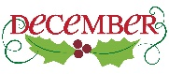

* **Our very successful ATN-MBON-OTN West Coast Region Workshop in Santa Cruz Nov. 7-9 brought together dozens of stakeholders from the Private/Commercial and Conservation Management Sectors with the regional marine biological Researchers to review the biological observational needs and capabilities in the Region and to solicit ideas on creating a West Coast Regional Biological Observing system. Carl provided a visionary IOOS context at the Workshop for a collaborative observing network that could integrate the spectacular array of biology-based scientific activities in the West Coast Region and serve the regional stakeholders. A small volunteer group was organized to continue the energy and enthusiasm developed at the Workshop and to define the mechanism through which the West Coast community will implement this exciting opportunity.**
* **Bill will be a judge for the selection of the winner of the BOEM and NASA “*Next Generation Animal Tracking Ideation Challenge*.” Satellite telemetry scientists are missing out on valuable data due limitations with current systems. A solution to these challenges using** [**CubeSat**](https://www.nasa.gov/mission_pages/cubesats/index.html) **technology would drastically improve our ability to protect and conserve endangered and vulnerable species.  This BOEM-NASA challenge has received more than 400 ideas and concepts. Review and final selection of  winners will take place in mid-December.**
* **Second round of interviews of the three short listed candidates for the NMFS-funded ATN DAC Science Coordinator have been completed. A final selection will be made the first week in December followed by an offer to the selected candidate. The position will be located at CeNCOOS.**
* **The ATN Program to pay the Argos satellite fees for marine animal tracking researchers is now supporting 6 programs and 96 tags.**
* **The AOOS ATN Workshop report preparation is in progress and will be closely followed by the GCOOS and PACIOOS Reports.**
* **We presented a project idea proposal for Ocean Obs ’19 at the Nov. 19 IOOC Meeting to “Establish an Integrated, Stakeholder-Driven U.S. West Coast Biological Observing System.” The IOOC co-Chairs will bring this and other proposals to the December 8 meeting of the Ocean Obs ’19 Program Committee for review.**
* **The ATN DAC will be ready to “on-board” telemetry researchers and Data/Metadata the first week in December.**
* **Bill is one of multiple authors on an Animal Tracking Community Paper for Ocean Obs ’19, “Animal-Borne Telemetry Integral to the Ocean Observing Toolkit.”**



**No. 26  
Dec 2018 & Jan 2019   
*Bill Woodward***

**From the ATN Wheelhouse……**

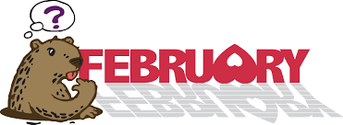

**We were fortunate to be able to keep the ATN engines running, although at lower RPM, during the challenging months of December and January. I’ve chosen to collapse those 2 months into one concise Wheelhouse Report highlighting key activities during that time**

* **Our ATN-MBON-OTN Santa Cruz Workshop spawned an energetic group of leading west coast biological scientists to lead the charge for a sustained bio-observing system by defining the requirements for a sustained West Coast Biological Observing System and the key scientific questions that need answering and identifying what is the baseline for measuring biological change. Bill is currently providing organizational guidance for this group of 12 (includes three IOOS RA Directors) which is now calling itself the California Current Large Marine Ecosystem (CCLME) Biological Observation Group. Our spirited meeting on Dec. 18 tasked Henry with drafting a Terms of Reference doc to frame some initial vision points. Activities were suspended during the shutdown but will be re-ignited in late February where we will review the draft TOR and work on the mechanics of moving forward**
* **A candidate has been selected for our NMFS-funded ATN DAC Data Coordinator position. Delayed by the shutdown, we will be executing the hiring process the first week in February. The Data Coordinator will be located at CeNCOOS/MBARI and will work very closely with the ATN and with Axiom**
* **The ATN Program to pay the Argos satellite fees for marine animal tracking researchers is now supporting 7 programs and 135 tags**
* **We’ve kicked off planning for our NERACOOS ATN-MBON-OTN Workshop to be held in New Hampshire. Planning committee is in place and draft agenda is prepared. Although likely to be in early May, we’re still hesitant to finalize a date until the looming threat of another gov’t shutdown goes away**
* **With great thanks to Helen Worthington our AOOS ATN Workshop final report is targeted to be available by mid-February. The GCOOS report is now being drafted and will be closely followed by the PACIOOS and West Coast Reports**
* **Extensive ATN Data Assembly Center (DAC) efforts ongoing with Axiom Data Science: A new detailed/updated workplan prepared for Jan-May 2019; weekly/bi-weekly progress calls ongoing; DAC on-boarding process for PIs; editing DAC Data Submission Guidelines and Data Management policies documents; daily review and feedback of beta version release of the DAC Data Portal**
* **Our team of NOAA, BOEM and NASA judges selected two first-place winners of the BOEM and NASA “Next Generation Animal Tracking Ideation Challenge.” Each was awarded $15K. NASA and BOEM are now working on the next level of competition that will assess the feasibility of the winning ideas**

**GLOSSARY:**

**MBARI:** Monterey Bay Aquarium Research Institute



**No. 27  
March 1, 2019   
*Bill Woodward***

**From the ATN Wheelhouse……**



* **We are pleased to announce the selection of Dr. Megan McKinzie for the NMFS/IOOS funded position of ATN Data Assembly Center (DAC) Data Coordinator. Megan has a significant amount of experience in the marine animal telemetry community and she earned her Masters Degree from Chris Lowe’s CSU Long Beach Shark Lab and more recently her PhD. from the School of Fisheries, Aquaculture and Aquatic Sciences at Auburn Univ. Megan will be posted at CeNCOOS and will be the primary interface between the ATN DAC operated by Axiom Data Science and the U.S. satellite and acoustic marine animal telemetry community.**
* **Our nine-member committee is in full planning mode for our NERACOOS ATN-MBON-OTN Workshop which is scheduled for May 6-7, 2019 at the University of New Hampshire. We have a draft agenda in place with a growing number of candidate speakers and Jackie will post the Save-the-Date notice the week of March 4.**
* **Through Helen Worthington’s excellent work we are catching up with production of our ATN Workshop Reports. The AOOS Workshop final draft will be ready this week for Molly and her team’s review and the GCOOS initial draft is close to being completed. The PACIOOS and the West Coast reports won’t be far behind.**
* **The ATN Program to pay the Argos satellite fees for marine animal tracking researchers is now supporting 10 programs and 172 tags. Researchers who are interested in applying for support from this program can go to** [**https://atn.ioos.us**](https://atn.ioos.us) **and click under Quick Links – Covering Argos Fees through the ATN to see if you are eligible and to download the pdf application form.**
* **Following some initial test-driving of customized google forms we will formally kick off our ATN Asset Inventory Project by mid-March. The effective coordination and sustainability objectives of the U.S. Animal Telemetry Network require knowledge of where the existing telemetry assets and science capabilities are located. Megan Treml, under contract to SECOORA, and Bill will be reaching out electronically to the satellite and acoustic community PIs asking for some basic information about their telemetry projects and assets. The primary audiences for this information are the ATN funding agencies, the ATN Steering Group (9 federal agencies and 4 non-federal organizations and the telemetry research community.**
* **Extensive beta-testing of the ATN DAC Data Portal being developed by Axiom continues with a goal towards releasing it live to the public on or about May 1.**



**No. 28  
April 1, 2019   
*Bill Woodward***

**From the ATN Wheelhouse……**



* **Bill & Mike Weise provided  two days of orientation forDr. Megan McKinzie the new ATN Data Assembly Center (DAC) Data Coordinator this month at CeNCOOS/MBARI, Moss Landing, CA. Megan is spending the week April 1-5 in Anchorage with Axiom for in-depth DAC orientation and interaction with the team.**
* **The Mid-Atlantic Telemetry Workshop (acoustic) hosted by the Smithsonian Environmental Research Center, NMFS Chesapeake Bay Office, MARACOOS and the ATN is scheduled for April 18-19, 2019 at the University of Delaware. For info. contact: Bill Woodward  or Matt Ogburn** [**bill.woodward@noaa.gov**](mailto:bill.woodward@noaa.gov)[**ogburnm@si.edu**](mailto:ogburnm@si.edu)
* **Bill will provide an ATN presentation and poster at the ONR Marine Mammal Program Review the week of April 22 in Alexandria, VA**
* **15 speakers (of ~25 planned)  are now confirmed for our NERACOOS ATN-MBON-OTN Workshop May 6-7, at the University of New Hampshire and thanks to Jackie’s tireless efforts the registration link is now available:** <http://neracoos.org/nebioworkshop2019>  **Draft agenda will be available by April 5.**
* **Final version of AOOS Workshop Report will be available April 8. GCOOS has been formatted and draft will be available soon.**
* **The ATN Program to pay the Argos satellite fees for marine animal tracking researchers continues to grow with 14 programs and 234 tags. Researchers who are interested in applying for support from this program can go to** [**https://atn.ioos.us**](https://atn.ioos.us) **and click under Quick Links – Covering Argos Fees through the ATN to see if you are eligible and to download the pdf application form.**
* **ATN Asset Inventory Project questionnaires will begin distribution to the acoustic and satellite telemetry communities no later than April 15.**
* **Extensive beta-testing of the ATN DAC Data Portal being developed by Axiom continues with a goal towards releasing it live to the public on May 1.**

APPENDIX D

ATN Coordinator Travel Summary

