ANIMAL TELEMETRY NETWORK (ATN) COORDINATOR REPORT #1 TO BOEM
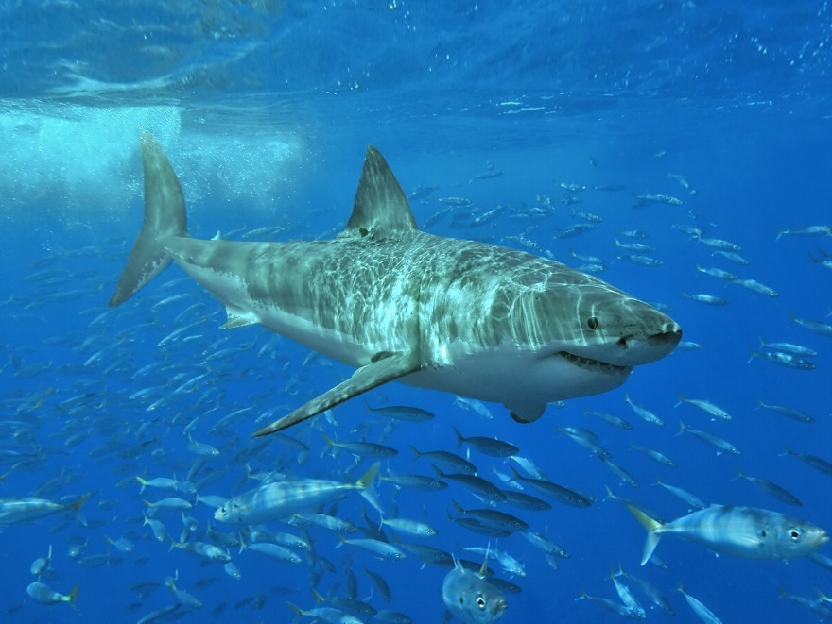
Photo by Terry Goss
June 2016 – September 2017
IAA No. M16PG00017, Mod 0001
Prepared by Bill Woodward, Integrated Systems Solutions, on Contract with the U.S. IOOS Program at NOAA

TABLE OF CONTENTS
Executive Summary…………………………………………………………………………………………………..………….….3
Introduction………………………………………………………………………………………………………………………….….5
I. Coordinate Overall Network Management…………………………………………..…………………..…………..6
- Implementation Plan-Steering Group……………………………………………………………………6
- Telemetry Asset Inventory..……………………………………………….…………………………………6
II.Successfully Create and Maintain Collaborations………………………………………………………………....7
- Workshops……………………………………………………………………………………………………………7
- Regional/Institutional Collaborations……………………………………………………………………8
- The FACT Acoustic Telemetry Network…………………………………………………………………8
- The ACT Acoustic Telemetry Network…………………………………………………………………..9
- Ocean Noise and Marine Life Task Force………………………………………………………………9
- Flower Garden Banks Coral Mortality Event – NOAA Stimulus Project………………….9
III.Engage and Lead Communications…………………………………………………………………………………….10
ATN Presentation schedule……………………………………………………………………………………….10
IV. Implement a National Data Management System……………………………….……………………………11
- The ATN DAC………………………………………………………………………………………………………11
- Regional Data Nodes………………………………………………………………………………………….13
- NCEI Data Preservation and Stewardship…………………………………………………………..13
- Examples of Successful Satellite Tag Data Recruiting through Community Action13
V. Identify High-Priority National ATN Program Assets……………………………………….…………………14
Candidate Priority Assets for Phase II Funding………………………………………………………….14
_______________________________________
Appendix A EXISTING TELEMETRY ACTIVITIES/NEEDS……………………………………………………..……16
I. The SECOORA-CARICOOS Regions
II.The MARACOOS Region
Appendix B PRIORITY OBSERVATIONS NEEDED…………………………………………………………….…...…20
I. The SECOORA-CARICOOS Regions
II.The MARACOOS Region
Appendix C From the ATN Wheelhouse……………………………………………………………………….…...….24
Appendix D ATN Network Coordinator Tasks…………………………………..………………………….….….…45
Appendix E Bill Woodward ATN Travel Summary……………………………………………………….…….….46
EXECUTIVE SUMMARY
The U.S. ATN vision is an observing system that can track aquatic animals and their habitats to provide data critical for the conservation and sustainable management of commercially harvested species, protected species, and other marine resources. It complements existing ocean observing assets and informs ecosystem-based management, fisheries and biodiversity, marine planning, ocean modeling and forecasting, and National Ocean Policy implementation. To accomplish this, the ATN is being implemented on three foundational pillars: Alliances and Collaborations, Data Management & Delivery, and Baseline Observations.
In accordance with the 5-year Implementation Plan (IP) approved by OSTP in December 2016, Phase I of the implementation began in the second quarter CY 2016 with the hiring of the full-time ATN network coordinator, Bill Woodward, with primary emphasis this first year on forming alliances/collaborations, creating governance and implementing the ATN data management/delivery vision.
Since coming aboard, I have been actively reaching out to as many of the existing regional self-organized collaborative telemetry groups (13 to date) as possible to begin the process of migrating these components into a unified network. This process and approach has included my participation in their regular meetings, informing them through discussions and presentations of the ATN program goals and developing mutually supportive alliances with them.
The successful coordination of the U.S. ATN requires an understanding of where the existing assets and science capabilities are located. To this end we have created an ATN asset inventory web tool
into which information about regional capabilities and tagging assets is being assimilated for display and analysis.
Consistent with the IP Phase I governance plan, we have created an ATN Steering Group (SG) to provide guidance and leadership on the development and implementation of the ATN. The SG has 13 members with representatives from 9 Federal agencies and four non-federal institutions. The first meeting, SG-1, was held in Washington, DC on June 5-6, 2017.
The ATN data management vision includes a regionally distributed data collection, management and sharing capacity that builds on and integrates as many existing data links as possible to enable local and regional needs to be addressed. At the heart of this system is a centralized Data Assembly Center (DAC) located at the Stanford U. Hopkins Marine Station. My responsibilities as ATN Coordinator include overseeing the operation and evolution of the ATN DAC. This DAC is a community resource where regional telemetry data is aggregated in a single place and one-stop-shopping is provided for access to all U.S. national animal telemetry data. The DAC both serves national stakeholder needs effectively as well as enables cost/time savings to principal investigators. The DAC is actively recruiting the submission of satellite and acoustic telemetry data from the broad telemetry community. This includes live BOEM/Navy Canaveral Shoals turtle satellite tracks that will be displayed beginning mid-September on the DAC website. In early 2017, BOEM and the U.S. Navy took a significant step when they both agreed to include language in their contracts to require their PIs to submit their data to the ATN DAC. In May 2017 we initiated steps with NOAA/NCEI to implement a permanent data archiving capability for the ATN DAC. This is in process and at the time of this writing, the DAC team is providing example datasets to NCEI for their assessment of the complexity of the ATN data.
“…….. BOEM and the U.S. Navy …. are including language in their contracts to require PIs to submit their data to the ATN DAC””

The ATN, and the DAC in particular, is part of a self-organized international effort to develop a common database schema to store and share acoustic, archival and satellite telemetry data among multiple international organizations. International partners include IMOS (Australia), OTN (Canada), ATN (U.S.) and ETN (Europe). This is a continuing effort on several fronts. A draft data exchange standard has been prepared by OTN, IMOS and ATN and a database web-app is in stages of being compiled on the various partner’s machines.
“…..live BOEM/Navy
Canaveral Shoals turtle satellite tracks….will be displayed beginning mid-September on the DAC website””
Regional acoustic telemetry data aggregation points, or “acoustic nodes,” are essential components of the distributed ATN data collection and management system. During the period of this report, the ATN has partnered with the Ocean Tracking Network (OTN), the IOOS Regions and multiple regional organizations to implement two regional “acoustic data nodes,” one in MARACOOS, called MATOS, and the other in SECOORA, called the FACT node. These nodes facilitate regional data aggregation, exchange and sharing, plus streamlined ‘orphan’ tag identifications. In addition to regional data collection, both of the nodes will submit data from their regions to the ATN DAC via their ERDDAP servers and this will soon be operational.
We initiated Phase II of the ATN in late CY 2016, with a top priority being the sustainable operations of the existing United States satellite and acoustic tagging capabilities. The ATN plan is to help keep existing efforts going and to add to them as identified and prioritized through Workshops and our ATN SG. During the period of this report, the ATN convened two community-building Workshops covering three of the U.S. IOOS Regions: MARACOOS, SECOORA, CariCOOS and three more are scheduled for CY-17/18. These Workshops are aimed at identifying and prioritizing regional telemetry research and potential keystone monitoring/observational needs, reviewing the existing global telemetry observing assets and scientific capabilities, documenting existing examples of stakeholder use of telemetry data. A summary of information obtained at the Workshops is included in Appendices A & B.

The outreach and communications during the period of this first report has focused primarily on personal outreach to engage, inform and to earn the trust of regional telemetry activities with the goal of creating as many collaborative ATN efforts as possible. These collaborations are outlined in this report. Our primary strategy has specifically included participating in their regular meetings to spread the news about the ATN goals, plans and activities. We regularly contribute items to the IOOS Director’s bi-weekly “Eyes on the Ocean” report, which has a distribution list of 1,500. Additionally, in November of 2016, we began preparing a monthly ATN update report called “From the ATN Wheelhouse.” Initially intended to keep the eleven IOOS Regional Association Directors informed, the monthly update is now regularly e-mailed to a list of 31 recipients. The complete set of “Wheelhouse” reports is in Appendix C.

Several candidate High-priority national ATN Program Assets and Infrastructure for Phase II future procurement have been identified from the broad extent of community interaction and engagement, including workshops, Steering Group Meeting, regional networks and Association meetings, participated in during the period of this report.

INTRODUCTION
This report is submitted to BOEM in accordance with reporting deliverables of IAA No. M16PG00017, Mod 0001. The report is organized according to the five Tasks assigned under the IAA:
- Coordinate Overall Network Management
- Successfully Create and Maintain Collaborations
- Engage and Lead Communications
- Implement a National Data Management System
- Identify High-priority National ATN Program Assets

The deliverables identified under IAA No. M16PG00017 are incorporated within this report and can be found by using this crosswalk:

- Coordinate Overall Network Management
The ATN, under the auspices of the U.S. IOOS, provides the mechanisms to facilitate and empower alliances among Federal, industry, academic, state local, tribal, and non-Federal organizations to coordinate aquatic animal telemetry infrastructure and operations. Regional self-organized collaboratives like FACT, ACT, iTAG etc. are examples of existing assets/infrastructure and the ATN seeks to work directly with these groups to, i) Maintain existing tagging efforts as a cohesive network, ii) Add to them as needed and defined by our Workshops and with guidance from our ATN Steering Group, iii) Work to improve connectivity among researchers in areas where it may be needed and, iv) Identify and Integrate disparate datasets in the regions.
Since coming aboard, I have been actively reaching out on a regular basis to as many of these regional groups as possible to begin the process of migrating these existing components of the U.S. marine animal telemetry community of practice into a unified network. This process includes participating in their regular meetings, informing them through discussions and presentations of the ATN program goals and developing mutually supportive alliances with them (See Section II below).
A.Implementation Plan-Steering Group
A major milestone in the ability of the ATN to execute the network coordination process was reached in late December 2016, when the White House Office of Science and Technology Policy (OSTP) approved and signed the Animal Telemetry Network Implementation Plan 2016-2021
Among other things, that Implementation Plan called for an ATN Steering Group (SG) to provide guidance and leadership on the development and implementation of the Plan in partnership with the IOOC member agencies, the IOOS Program Office, IOOS Regional Associations (RAs) and regional subject matter experts. The IOOC formed an ATN Steering Group Task Team in 2016 that was responsible for identifying and appointing the initial Steering Group members, both federal and non-federal, with concurrence from the IOOS Program Office and the IOOC. During the period of this report, the ATN Steering Group Task Team developed Terms of Reference for and established the first ATN SG. This ATN SG includes 13 members with representatives from 9 Federal agencies and four non-federal institutions. The SG held its first meeting, SG-1, in Washington, DC on June 5-6, 2017, and I was elected to be the SG Chair-person for this and the next two meetings. Next SG Meeting is scheduled for November 8-9, 2017. Meeting minutes for SG-1 are here: https://ioos.noaa.gov/project/atn/#meetings
B.Telemetry Infrastructure/Asset Inventory & Observation Priorities
The successful coordination of the U.S. ATN requires an understanding of where the existing infrastructure, assets and science capabilities are located. While only limited formal surveys of ATN activities and regional assets have been taken to date, analyses on information gathered at the two Workshops we’ve hosted so far was adequate to support valuable analyses of their respective regional animal telemetry activities, assets and needs and priority observation requirements (see Appendices A & B). For the upcoming Workshops, we envision conducting formal asset and observation needs surveys in advance of the Workshops to gather information that will then be discussed and analyzed during the workshop. These survey results as well as the information already gathered in our first two Workshops will be assimilated into our developing ATN Asset Inventory web tool for display and review.
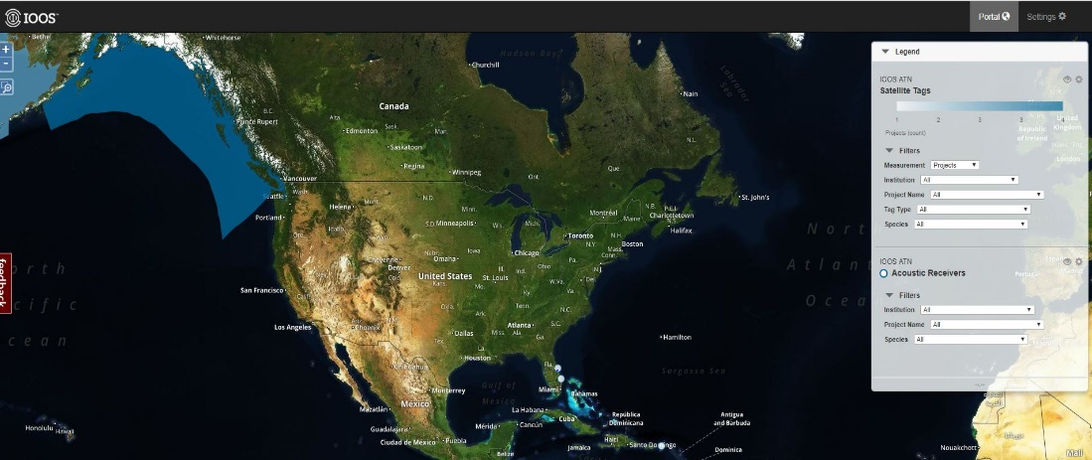
ATN ASSET INVENTORY PORTAL

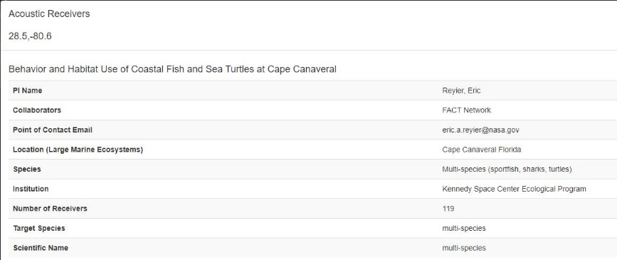

- Successfully Create and Maintain Collaborations
A.Workshops
During the period of this report, the ATN convened two community-building Workshops covering three of the U.S. IOOS Regions. One addressed the MARACOOS Region (Annapolis, MD, Feb. 21-22, 2017) and the other the combined SECOORA-CARICOOS Region (Tampa, FL, March 28-29, 2017). Another three ATN Workshops are currently scheduled: AOOS Region (Anchorage, AK, Dec. 5-6, 2017), GCOOS Region (New Orleans, LA, January 23-24, 2018) and PACIOOS Region (Honolulu, HI, Summer 2018) The workshops are being convened with the following objectives:
- Identify and prioritize regional telemetry research and potential keystone monitoring / observational needs.

- Review the existing global telemetry observing assets and scientific capabilities, and provide a state-of-the-region analysis.
- Document existing examples of stakeholder use of telemetry data (e. g. understanding fish distribution, mortality, migration, design of protected areas, definition of essential habitat for species protected by the ESA & MMPA, socioeconomics, fisheries management, and others).

- Identify data management challenges, and showcase regional capabilities and tools with global linkages for data management, sharing and collaboration. Consider needs common to other regions, and discuss strategies for applied, collaborative research across geographies and disciplines

Information collected at the Workshops is distributed throughout this report with specific information in Appendices A & B.
B.Regional/Institutional Collaborations
Also during the period of this report and in accordance with the Network Coordinator task to ‘Facilitate, Develop & Support Multi-Agency and Institutional Collaborations that Conduct and/or Promote Animal Telemetry,’ the ATN engaged and established collaboration with the following national and international regional telemetry networks and programs:
- ACT (Atlantic Cooperative Telemetry) – MARACOOS
- FACT (Florida Atlantic Coast Telemetry) – SECOORA
- iTAG (integrated Tracking of Aquatic animals in the Gulf of mexico) – (GCOOS)
- USCAN (U S Caribbean Acoustic Network) – CARICOOS
- GLATOS (Great Lakes Acoustic Telemetry Observation System) – GLOS
- NOAA/Office of National Marine Sanctuaries
- Atlantic White Shark Conservancy – Chatham, Massachusetts
- Shark Research & Conservation Program (U. of Miami)
- NOAA/Marine Mammals Lab
- Coonamessett Farm Foundation – Falmouth, Massachusetts
- Ocean Tracking Network – Canada
- IMOS/IMAS (Integrated Marine Observing System/Inst. For Marine and Antarctic Studies) – Australia
- MEOP (Marine Mammals Exploring the Oceans Pole to pole) - Sweden
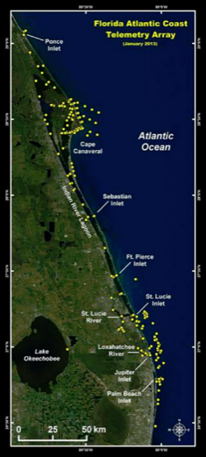
C.The FACT Acoustic Telemetry Network
The Florida Atlantic Coast Telemetry (FACT) Network, which currently includes 45 separate organizations with a total of 900 coastal acoustic receivers from the Florida Keys to Virginia is the largest single community-organized and managed marine animal tracking consortium in the U.S. They partner very closely with SECOORA and by earning their trust the ATN has now convinced them of the value of submitting FACT telemetry data to the ATN DAC. The data path will be via the SECOORA-FACT acoustic telemetry node which the ATN has helped to become operational by working closely with the Florida Fish and Wildlife Research Institute (FWRI), the Canadian Ocean Tracking Network (OTN) and the SECOORA team.

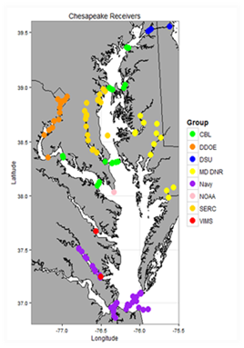
D.The ACT Acoustic Telemetry Network
By similarly earning the trust of the Atlantic Cooperative Telemetry (ACT) network consortium and by providing a small amount of support funding ($40K), the ATN has engaged in a very successful joint development with ACT, MARACOOS, the NOAA Chesapeake Bay Office, the Atlantic States Marine Fisheries Commission and RPS/ASA to complete the development of MATOS (Mid-Atlantic Telemetry Observation System). MATOS is a web-based tool that allows telemetry researchers to manage acoustic tag and receiver data in a searchable, secure database, that streamlines data analysis, synthesis and data sharing. It also incorporates ocean and coastal observation data, providing critical information to users about environmental condition where tagged animals are detected. MATOS is now operational and is being populated with data from the ACT Network of acoustic receivers.
E.SOST Ocean Noise and Marine Life Task Force
The Interagency Task Force on Ocean Noise and Marine Life was first convened in 2014 to increase coordination and communication across federal agencies in addressing the issues related to the potential impacts of anthropogenic noise on marine life. The Task Force includes a total of 16 Federal Agencies and I am the IOOS representative to it. My inputs are organized and coordinated through the internal NOAA group responsible for implementing the ‘NOAA 10 Year Ocean Noise Strategy.’ I have recently submitted the following two ATN activities for consideration in the NOAA Ocean Noise Strategy (ONS) Workplan:
I. NOAA ONS WORKPLAN PROJECT: Operationalize a National Archive for Passive Acoustic Monitoring Data
Proposed ATN Activity: "Explore the mechanism/value of connecting the PAM-NCEI activities with our ATN DAC-NCEI activities using the Tethys database schema"
II.NOAA ONS WORKPLAN PROJECT: Use passive acoustic monitoring in baseline assessments of habitat use patterns by managed fish and invertebrates, prioritizing areas with pending noise-producing federal activities that necessitate NOAA consultations
Proposed ATN Activity: "Implement a regional case study to evaluate the extent to which combining ATN telemetry data with passive acoustic data can improve our ability to assess the impacts of noise on animal movement/behavior and habitat use IOOS”
Response from NOAA is pending.
F.Flower Garden Banks Coral Mortality Event – NOAA Stimulus Project
Several partners (Flower Garden Banks National Marine Sanctuary, Sanctuaries MBON Team, Office of National Marine Sanctuaries, U.S. IOOS-MBON/ATN, GCOOS/TAMU, Smithsonian MarineGEO) are implementing a targeted project funded with internal NOS stimulus money. The project will host a January 2018 Symposium in Galveston which will bring together the scientists and managers involved in the response to the dramatic mortality event in 2016 that impacted thousands of coral colonies, sponges, crustaceans, etc., in the Flower Garden Banks Sanctuary. Objectives are to finalize analyses, and to scope risk reduction and response measures applicable to the FG Banks and similar sensitive marine areas. Observations collected during the event will be discussed and assessed during the symposium, including recorded noise data as well as movement of animals, to see if they may reflect the causes and effects of stressful events. The ATN action is to discover and provide any and all animal movement data from the region that can be useful in the analyses.

- Engage and Lead Communications
The ATN IP calls for a Communications, Outreach and Education Strategy to be formulated within the first few years of operation by the ATN SG and the ATN Network Coordinator, in collaboration with ATN operators, partners, data users, and stakeholders. During this first year of ATN operation our communications has been focused primarily on personal outreach to engage, inform and to earn the trust of regional telemetry activities with the goal of creating as many collaborative ATN efforts as possible. These collaborations are outlined in Section II above and our primary strategy has specifically included participating in their regular meetings and giving presentations to spread the news about the ATN goals, plans and activities. We regularly contribute items to the IOOS Director’s bi-weekly “Eyes on the Ocean” report, which has a distribution list of 1,500. Additionally, in November of 2016, I began preparing a monthly ATN update report called “From the ATN Wheelhouse.” Initially intended to keep the eleven IOOS Regional Association Directors informed, the monthly update is now regularly e-mailed to a list of 31. (See Appendix C). I also had the opportunity to be a co-author on a short article, Ocean Observations Using Tagged Animals, published in the July 2017 Issue of the Oceanography Magazine.

During the period of this report, I’ve also begun working with Kate Culpepper, our IOOS Communications leader, to identify a broader, multi-faceted outreach strategy that is integrated with the IOOS, NOS and NOAA efforts. This will include among other things, a complete refresh of the ATN content on the IOOS.noaa.gov website, animal tracks on the NOAA SOS (Science on a Sphere), opportunities to promote ATN partner telemetry stories via existing IOOS and NOAA social media outlets and an ATN ‘tile’ on the IOOS home page from which users can access the ATN DAC site directly. We would also look to engage our media outlets with those of the ATN partner agencies.
We will also develop formal and informal educational strategies through schools, aquariums, exhibits of tagged animal tracks at museums, etc.

ATN Presentations by Bill
MARACOOS Annual Meeting, Annapolis, MD – May 2016
FACT Spring Mtg, Jupiter, FL – June 2016
NOAA/North-Atlantic Regional Team (NART) Workshop, Fall River, MA – August 2016
U.S. Caribbean Acoustic Network Mtg, St. Croix – October 2016
MATOS-ATN Workshop, Annapolis, MD – February 2017
GLATOS Annual Meeting, Ann Arbor, MI – February 2017
SECOORA-CARICOOS ATN Workshop, Tampa, FL – March 2017
MARACOOS Board Mtg, Annapolis, MD – May 2017
iTAG Annual Meeting, St.Pete, FL – May 2017
MBON All Hands Mtg, Wash., DC – May 2017
Fact Spring Meeting, Jupiter, FL – June 2017
6th Biologging Symposium, Konstanz, Germany – September 2017 ATN POSTER
Publications
OCEAN OBSERVATIONS USING TAGGED ANIMALS - Roquet, F., L. Boehme, B. Block, J.-B. Charrassin, D. Costa, C. Guinet, R.G. Harcourt, M.A. Hindell, L.A. Hückstädt, C.R. McMahon, B. Woodward, and M.A. Fedak. 2017. Ocean observations using tagged animals. Oceanography 30(2):XXX–XXX, https://doi.org/XXX.

IV. Implement a National Data Management System
The ATN data management vision includes a regionally distributed data collection, management and sharing capacity that builds on and integrates as many existing data links as possible to enable local and regional needs to be addressed. At the heart of this system is a centralized data assembly center (DAC) where the regional data is aggregated in a single place and one-stop-shopping is provided for access to all U.S. national animal telemetry data thereby effectively serving national stakeholder needs.
A.The ATN DAC
The ATN DAC is a significant community resource providing data management assistance to the telemetry community, which equals cost/time savings to principal investigators. Specific benefits to the community include:
- Data Archiving
  - Eliminating need/cost to create your own complex data storage system
  - Providing regulatory compliance with public availability (PARR)regulations
- Efficient Metadata Managing/Archiving/Sharing
  - Providing standardized metadata & reporting formats
  - Enabling easier deciphering of other PI’s data
- Interoperability with other Telemetry Data Centers
  - Eliminating effort required to submit your data to multiple centers
- Efficient Sharing of your Data with Collaborators
- Streamlined Linking of Telemetry Data with a Wide Range of
Environmental Covariates
- Availability of Tools for Mapping, Analysis, QA/QC & Visualization
- Simplified Data Discovery/Exploration
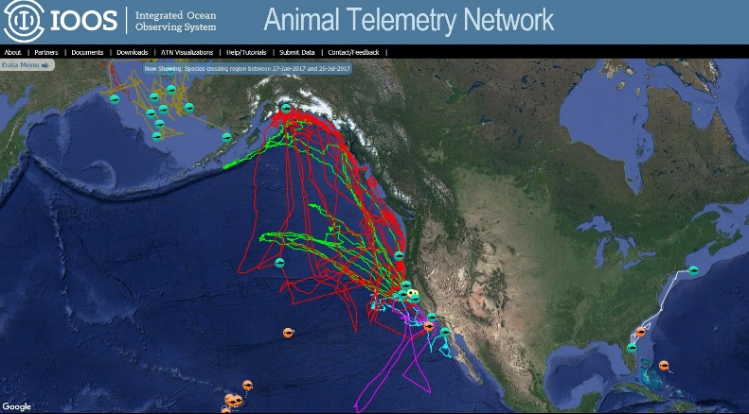
My responsibilities as ATN Coordinator include overseeing the operation and evolution of the ATN DAC. The DAC was established in 2014 at the Hopkins Marine Station of Stanford University in Monterey, CA under the direction of Dr. Barbara Block, with a focus on leveraging efforts conducted during the Census of Marine Life Program (e.g., TOPP, OBIS…) and establishing best research practices for data archival and distribution of animal telemetry data using standard data management protocols. A goal is to acquire datasets from animal borne tags and from animal acoustic detections from any valid underwater receiver providing data primarily in U.S. waters.
The ATN DAC is an online, distributed system that ensures uniform access to U.S. animal telemetry data from anywhere in the world. The system is currently accessed via an intuitive web portal http://oceanview.pfeg.noaa.gov/ATN/ that has thousands of data sets from 45 animal taxa spanning 1997 – 2017. This portal demonstrates the capacity for live biological monitoring of animals swimming in U.S. and international waters, and the collaborative opportunity that exists for utilizing ATN telemetry datasets and their behavioral and environmental data streams. In January 2017 the DAC was declared to be operational. Based on the successful development we have observed from two site visits with the DAC team at Hopkins, we have begun making plans to identify a sensible and logical transition trajectory that we can apply to move the DAC from its current research/developmental implementation in the Hopkins research environment to a location and environment that is dedicated to operational execution/support and customer service. Estimated time is 6-12 months.
Although relatively mature, the managing and sharing of telemetry data on a global scale is still evolving. The ATN is part of a self-organized international effort to, among other things, develop a common database schema to store and share acoustic, archival and satellite telemetry data among multiple international organizations. International partners include IMOS (Australia), OTN (Canada), ATN (U.S.) and ETN (Europe). This is a continuing effort on several fronts. A draft data exchange standard has been prepared by OTN, IMOS and ATN and a database web-app is in stages of being compiled on the various partner’s machines. Our DAC team at Hopkins is working together directly with IMOS on that effort.
Because the ATN is a part of the larger global telemetry efforts, it is essential that we be represented in these international processes. To that end, in late September I will attend a workshop entitled “A future for a common bio-logging language? Discussions about data standards and interoperability in the bio-logging world” at the 6th International Bio-Logging Science Symposium on Lake Constance, Germany, 25–29 September 2017. Also, I am a member of the OTN International Data Management Committee (IDMC) and will attend their next meeting in Halifax on October 16-17, 2017.
B. Regional Data Nodes
Regional data nodes are essential components of the distributed ATN data collection and management system. During the period of this report, the ATN has partnered with the Ocean Tracking Network (OTN), the IOOS Regions and multiple regional organizations to implement two regional “acoustic data nodes,” one in MARACOOS, called MATOS, and the other in SECOORA, called the FACT node. These nodes facilitate regional acoustic telemetry data aggregation, exchange and sharing, plus streamlined ‘orphan’ tag identifications. Both of the nodes will submit data from their regions to the DAC via their ERDDAP servers and this will soon be operational. While these tools will significantly increase the capabilities of the regional networks, each of them does require a data manager to make it all work. Providing support for these data managers would be a natural thing for the ATN to do (see Section V. B). Additionally, the nodes are OTN compliant and thus can also submit data to the Canadian OTN database. The ATN will continue to work with the OTN and partners in other IOOS regions to assist with implementing additional nodes as needed.
C. NCEI Data Preservation and Stewardship
During the period of this report, in coordination with the ATN DAC team, I initiated the steps to set up the permanent archiving process for ATN DAC data at NCEI. We have created a formal Advanced Tracking and Resource for Archive Collections (ATRAC) request at NCEI. This triggers scheduling of an 'archive appraisal meeting' at which a formal decision to proceed will be made. We will use Bob Simons' (SWFSC/ERD) prototype ERDDAP Archive tool and will continue to work closely with him as we implement the process. Data complexity could be an issue but is not currently considered a barrier to implementation. NCEI has indicated that because the ATN is part of the IOOS PO then there would likely be no additional cost to the ATN for implementing this service. At the time of this writing, the DAC team is providing example datasets to NCEI for their assessment of the complexity of the ATN data.
D. Examples of DAC Satellite/Acoustic Tag Data Recruitment via Community Action

- Live white shark satellite tracks – Greg Skomal (complete)
- Live porbeagle shark satellite tracks – James Sulikowski (complete)
- Live mammal satellite tracks – Robin Baird (in process)
- Live turtle satellite Tracks –BOEM/Navy/Canaveral shoals: (in process)
- Live turtle satellite tracks – BOEM/Dare County: Jake Levenson (in process)
- Profile data from satellite tagged white sharks – Kim Holland (in process)
- Profile (12,000) data from satellite tagged turtles - NOAA/NE Fisheries Science Center (in process)
- Acoustic detection data from BOEM glider- (in process)
- FACT Network acoustic detections – (in process)
- ACT Network acoustic detections – (in process)

V. Identify High-Priority National ATN Program Assets

A top priority of the ATN is the sustainable operations of the existing United States tagging capability and receiver arrays that have been deployed during the past 15 years, mostly in incremental pieces for coastal ocean research. Phase II (2017-2019) of the ATN implementation plan calls for identifying and prioritizing infrastructure/assets that need to be supported in order to successfully sustain ATN operations.
These priority baseline observations will be of two types. The First Type will be consistent, long‐term observations from satellites, archival tags, and acoustic systems intended as stable resources rather than responses to short‐term requirements. Review and consideration of changes in these consistent, long-term priority baseline observations will occur on a regular cycle, and be initiated only after careful consideration and consultations among the SG, U.S. IOOS RAs, Federal agencies, non‐Federal entities, and stakeholders.
The Second Type of priority baseline observations will be focused observations of animal responses to
unexpected events such as warm-water anomalies (e.g., El Niños), oil spills (e.g., the Gulf of Mexico
Deepwater Horizon oil spill), and natural disasters. The small and mobile nature of acoustic receivers and arrays, satellite and archival tags, and tagging equipment provides an inherent flexibility that can be used by the ATN. In limited cases or in response to an urgent national need, the ATN may request that assets held by the various regional operators and institutions be tasked with limited‐duration, targeted tagging efforts. The U.S. IOOS RAs and SG can nominate targets, with scope and tasking determined by the voting members of the SG.
The following candidate infrastructure and assets have been identified from the broad extent of community interaction and engagement, including workshops, Steering Group Meeting, regional network and Association meetings, enjoyed during the period of this report.

Candidate Priority Infrastructure & Assets for Phase II Funding

A. Georgia DNR Acoustic Receiver Line off St. Simons Sound, GA – Est. $70K/year

[Cost estimate includes 3 months’ salary for the PI, vessel support (both large and small) for servicing the offshore (16 VR2W) and shipping channel arrays (12 VR2W), miscellaneous supplies for housing and mooring constructions, dive pay for the diver corps, and some travel.]
Supporting text from Dr. Eric Reyier, Kennedy Space Center Ecological Program:

“Our research at Cape Canaveral (supported by BOEM, NASA, and US Navy) has benefited greatly by coastal receiver lines maintained by Georgia DNR and South Carolina DNR. My understanding is that while the SC line has received a funding extension, the line off St. Simons Sound, GA (managed by Chris Kalinowsky at GADNR) may be decommissioned as early as this December. I reviewed our data and this line alone has detected 109 animals in 10 species that were originally released here at the Cape. Almost all of these are federally managed species with defined EFH. I know this array also regularly detects animals from many other groups, including ESA-listed turtles and sturgeon. The attached animation of our finetooth sharks shows what type of info these coastal arrays can provide, and demonstrates how much time our sharks spend in GA nearshore waters. The same is proving true for many of our other species. Our take home….we think that this GA receiver line advances the research of many user groups along the US Atlantic coast, and its removal will be a step back for acoustic telemetry research in our region. We just wanted to make you aware of this in hopes it will be part of the ATN conversation moving forward.”

B. Data Manager/Diplomat Funding for the SECOORA and MARACOOS Acoustic Data Nodes – Est. $150K/year

With partnerships among SECOORA, the Florida Fish and Wildlife Research Institute (FWRI), Axiom Data Sciences, OTN, MARACOOS, the NOAA Chesapeake Bay Office, the Atlantic States Marine Fisheries Commission and RPS/ASA and the ATN, acoustic telemetry data Nodes are now operational for both the ACT and FACT community-based telemetry networks. Each of these Nodes are now being populated with acoustic datasets from their regions. For the Nodes to be effective however, each Node requires some small annual O&M funding plus a dedicated Data Manager/Data Diplomat to be a trusted interface with their communities who will recruit PIs to submit their data, will encourage data sharing and will insure that the data is properly managed.

Currently, temporary O&M support for the nodes comes from internal RA funding, and the ‘data management’ responsibilities are discharged by volunteers who also are full-time state and federal employees: ACT (Kevin Schabow, NOAA/CBO) and FACT (Joy Young, FWRI). This is neither a satisfactory nor a sustainable way to operate these very capable telemetry Nodes. Since they are essential components of the U.S. Animal Telemetry Network infrastructure it is appropriate for the ATN to consider full funding for the O&M for these nodes and full or partial funding for these Data Manager positions to insure sustainability of these nodes.
C. Argos Service Funding for Priority Satellite Telemetry Activities of Agencies Funding the ATN

Similar to the receiver lines for acoustic telemetry detection, the satellite data collection and location service of Argos is an essential element of the U.S. national animal telemetry infrastructure. Consequently, providing sustained, robust Argos service that will insure the stability of high priority, long-term satellite tagging efforts in the ATN is an appropriate candidate for ATN funding. During the period of this report, I have had discussions about this with the Argos Joint Tariff Agreement Chairperson, Eric Locklear. In particular, he was receptive to the concept of negotiating a unique preferential Argos tariff rate for U.S. ATN members, as well as a fixed price, “all you can eat” Argos service contract for ATN satellite taggers. CLS is currently reorganizing their Argos tariff structure and will soon propose a new approach to the JTA members. We will be evaluating that as information becomes available.

D. Funding to Create an Off-the-Shelf Supply of Easily-Accessible Satellite and Acoustic Tags, and Acoustic Receivers for Quick Reaction Determination of Animal Responses to Anomalous Environmental Events (e.g., strandings, hypoxia, warm water,…)

Purchasing telemetry tags and acoustic receivers can be the single most expensive and time-consuming part of implementing animal telemetry programs. The ATN Steering Group, and others, have recommended that the ATN fund the establishment of a community inventory of tags and receivers that could be made available with short notice for quick reaction, high priority applications. This is a valuable concept that with careful planning and organization would be an appropriate candidate for ATN funding.

APPENDIX A
EXISTING TELEMETRY ACTIVITIES/NEEDS
Science + Management + Compliance + Stock Assessment + Spatial Ecology

I. THE SECOORA-CARICOOS REGIONS
- BOEM: supports conservation and the use of applied data to make informed decisions about the environment and the ocean that comply with ESA, Magnuson-Stevens Fishery Conservation and Management Act, and NEPA. BOEM has funded many renewable energy telemetry studies in the Atlantic to determine which areas are important to migratory marine species and how to work with developers on these issues
- IGFA – International Great Marlin Race (IGMR) Largest citizen science billfish conservation project in the world: Learn more about the diversity of migratory patterns and the factors that influence them to develop better management strategies
- U.S. Navy/NAVFAC/Atlantic Marine Species Monitoring Program: The Navy is responsible for compliance with a suite of Federal environmental laws and regulations that apply to marine mammals and other marine protected species, including the Endangered Species Act (ESA) and the Marine Mammal Protection Act (MMPA). Various individual range complex monitoring plans have been developed to address the monitoring requirements of the ESA and MMPA across the various geographic regions where the Navy trains. Monitoring plans involve a combination of field techniques, including among other things, short and long-term marine animal tagging telemetry, designed to support range complex-specific monitoring as well as contribute data and information to the broader scientific community. Field monitoring methods to gather telemetry data on occurrence, distribution, abundance, density, spatial use, foraging ecology, and baseline behavior of cetaceans as well as movement, habitat use, and by-catch reduction measures for sea turtles.
- FACT: The Florida Atlantic Coast Telemetry (FACT) Array is a partnership of 45 marine research organizations using passive acoustic telemetry to reveal the movement and behavior of fishes and sea turtles in US South Atlantic, Bahamas, and Caribbean Sea. The members collectively maintain 900 underwater acoustic receivers. The telemetry data collected provides information about a species’ habitat preferences, migration patterns, stock mixing, and survival. In addition to advancing basic knowledge of these species, these results help guide management strategies for species of economic value to the region or for those requiring special conservation attention.
- NOAA/NMFS: Telemetry data is used for marine mammal stock assessment in the U.S. Atlantic, from Florida to North Carolina, the Gulf of Mexico, and the U.S. Caribbean, including Puerto Rico and the Virgin Islands. Telemetry data was used to establish the critical habitat for the Gulf of Mexico Bryde’s whale by discovering their ranging patterns. Telemetry data also informs Take Reduction Teams (TRT), MMPA permit applications, ESA Section 7 consultations, release decisions, and animal health and also can be used to better understand the impacts of long-line fishing on pilot whales by identifying their seasonal movements and interactions with the fishery.
- NOAA/NPS/USVI: A Coral Reef National Monument study to examine fish movements within and between the park, monument, and surrounding waters collected acoustic tracking data illustrating fine- to broad-scale movement patterns across different habitats and management units, which established an ecological connectivity between the two; A continuing study in St. John at Coral Bay which is examining fish movements and residence times to evaluate the efficacy of monument boundaries established a communication and understanding that different animals with different life history patterns require more diverse understanding and management
- National Park Service (NPS): The Southeast Region of the NPS uses telemetry data to assess the effectiveness of specially managed zones, such as Marine Reserves and Marine Protected Areas and to better understand habitat use, climate change, and impacts of human use, invasive species, stranding research, and gulf restoration. In the Caribbean Region, the NPS is using telemetry data from threatened and endangered species as well as ecologically and commercially important fish to quantify habitat usage and home range patterns, to determine migration timing and spawning aggregation sites, and to evaluate site fidelity and connectivity between Marine Protected Areas.
- Florida Fish and Wildlife Conservation Commission (FWC): manatee conservation program dedicated to protecting and conserving the Florida manatee through scientific research and education; Satellite telemetry has enabled them to determine seasonal ranges of manatees in relation to foraging sites and to measure how manatees respond to approaching watercrafts; they are also trying to infer what will happen to these animals when there is a: loss of habitat
- South Carolina Department of Natural Resources: A three-year, multistate sturgeon study in North Carolina, South Carolina, and Georgia study involved North Carolina State University (NCSU), the North Carolina Division of Marine Fisheries (NCDMF), and the University of Georgia (UGA). Their objectives were to better address the distribution and migration range, identify critical habitats, and document the degree of inter-basin transfer occurring for both species of sturgeon. Total combined number of fish tagged was over 1,200 and 620 receivers were installed in North Carolina, South Carolina, and Georgia in potential sturgeon spawning ground. Through the ACT network, they obtained and shared detection data that verified that there was a north/south migration. This data can also be used by NOAA/NMFS and other agencies to determine how dredging impacts the presence of animals off the coast over the years.
- Massachusetts Marine Fisheries: Tracking movement of white sharks in the western North Atlantic. Because the distribution of these animals goes from the Gulf of Mexico to Canada the telemetry data provides great connectivity between north and south organizations. The data are used to examine fine- and broad-scale movements, habitat use, site fidelity, residency, and feeding behavior. Results illustrate both ecological and a human recreational points of view, and have inspired interest in researching local movement versus abiotic and biotic parameters that drive the animals.
- Chicago Zoological Society – Sarasota Dolphin Research Program: Forty years of telemetry data has been collected in combination with evolving telemetry techniques in Sarasota Bay which is a natural laboratory setting for bottlenose dolphins. Using VHF and satellite-linked tags, they defined the bottlenose dolphin stock in St. Joseph Bay, FL and also near Brunswick and Sapelo Island, Georgia Beyond the SECOORA region, satellite-linked tags were deployed in 2013 near Mississippi Sound to define dolphin ranging patterns relative to the Deepwater Horizon Oil Spill. These studies can be very helpful for the post-intervention follow up monitoring that determines whether or rehabilitation of the animals is necessary.
- iTAG/FWC: iTAG is an active informal regional animal tracking consortium, created to demonstrate how the added value of collaboration among many can result in better science and conservation. The group uses telemetry data to support their research interests and those of the FWC including spawning site selection and rebirth rate, integrating telemetry and genetic tracking to understand spawning population abundance over time influence of temporal and spatial scales, and group behavior and predator/prey dynamics
- Commercial and recreational fishing industry: answer baseline questions about where the fish are going and what they are doing correlated with physical and chemical ocean conditions; telemetry data helps to establish migration patterns, identify outliers, find fish hotspots, determine population structure and estimates of fish mortality and unit stock identification plus fish aggregation around topographic features
- USGS: Many projects (Everglades, Buck Island, Dry Tortugas) involving modeling of marine turtle movement and habitat use and describing how important connectivity is to their research. Both satellite and acoustic tags as well as standard mark-recapture studies, are used to collect data on abundance, density, survival, population growth rates, habitat use, and stock identification of sea turtles. This information is vital for understanding whether conservation measure are effective.
- Bonefish & Tarpon Trust: One BTT focus is on flats fisheries, including bonefish, tarpon and permits. They fund and conduct research that is directly applicable to conservation management due to the annual economic impacts. The Florida Keys, Belize, and the Bahamas generate more than $465 million, $50 million, and $141 million a year respectively. Bonefish, tarpon, and permits are good umbrella species and protecting their habitats provides system-level protections. The BTT argues that Cuba provides the perfect location to conduct research comparative to the Florida and Caribbean areas because all the areas of study in Florida are in anthropogenically impacted regions, including the Everglades. There are still locations in Cuba that are very similar to the Everglades, without any anthropogenic effects, and could provide insight into what would be expected if the Everglades were to be restored.

II. THE MARACOOS REGION
- ACT Network: 119 researchers; 14,225 tags deployed since 2005
- U.S. Navy/NAVFAC/LANT: 75 receivers in the lower Chesapeake Bay and off the coast.
- Smithsonian Environmental Research Center: In support of fisheries management, coastal resource planning processes and conservation, animal movement research at SERC using acoustic, satellite and PIT telemetry includes: Animal behavior, habitat use and connectivity, population and community dynamics, environmental variability and animal movement and the role of movement in ecosystem structure, function and resilience. 80 species; In support of: Responses of anadramous fish to dam removal, fisheries management, fisheries management, fish and crustacean utilization of restored oyster reefs, habitat use and trophic interactions of invasive fish and impacts of climate change on migration and habitat use. Species include: blue catfish, carp, cownose rays.
- New England Aquarium & Massachusetts Div. of Marine Fisheries: Striped bass, American shad, white shark, sand tiger sharks, thorny skate, black sea bass, cod, haddock, cusk; learn about movement, habitat use, stock structure, discard mortality; satellite and acoustic telemetry
- Univ. of Delaware: using telemetry to facilitate avoidance measure for bycatch of Atlantic sturgeon; link ocean conditions and species occurrence, make a predictive model and then a bycatch reduction tool to avoid fishing where the sturgeon are.

APPENDIX B

PRIORITY OBSERVATIONS NEEDED

I. THE SECOORA-CARICOOS REGIONS

- BOEM: Use telemetry and tagging to understand their environmental impacts on migratory patterns of animals. Collaborating with the ATN helps with long-term monitoring and ecosystems-based management. The partnerships with the Navy, NASA, and UF through the Florida Atlantic Coast Telemetry (FACT) array has given them access to 100 Vemco receivers in various habitats, tracking 500 fish of fifteen different species. BOEM has funded many renewable energy telemetry studies in the Atlantic to determine which areas are important to migratory marine species and how to work with developers on these issues. Future studies will include more glider research and passive and active acoustic monitoring of soniferous fish, sea turtle tagging with satellite telemetry through the Atlantic Marine Assessment Program for Protected Species (AMAPPS), and additional pinniped work under AMAPPS; there is also a demand for telemetry efforts for highly endangered species such as the North Atlantic right whale.
- U.S. Navy: Ongoing field monitoring methods to gather telemetry data on occurrence, distribution, abundance, density, spatial use, foraging ecology, and baseline behavior of cetaceans as well as movement, habitat use, and by-catch reduction measures for sea turtles. Satellite tags are also successfully used for research on bottlenose dolphin, Cuvier’s beaked whale, and short-finned pilot whales. Significant data has been collected from the pilot whales about the individual variability, movement behavior, and habitat models that confirmed that there are actually different stocks of these animals that were previously managed as one stock. Future studies will include a mix of DTAGs (recording depth, temperature, and three-dimensional motion) providing short-term, fine scale behavior data, satellite tags showing medium-term movement, and photo-identification giving long-term residency patterns.
- NMFS: Currently manages twenty-six cetacean species and ninety stocks, and their priority marine mammal stocks are the North Atlantic right whale, sperm whale, Bryde’s whale, bottlenose dolphin, and small bay/estuary and coastal stocks. Dive recording and reporting telemetry tags can provide more accurate abundance estimation for deep diving marine mammals and sea turtles. NMFS is looking forward to technical improvements in tags including better ways to tag free-swimming cetaceans, longer battery life and use tags/animals as ocean sensors. They continue working on development of LIMPET tag attachment types, as well as behavioral tags to improve on migratory models and abundance estimate.
- Commercial and Recreational Fishing Industry: Understanding the analysis, results, and connectivity of oceanographic data is very important, which is regularly illustrated by using the daily GOES satellite data in the GCOOS and SECOORA regions. The application of real-time observation data should be planned for in proposal budgets to complement hourly, daily, and weekly data. Successful long-term observation/monitoring requires strong collaborations with all agencies, organizations, and researchers (like the Marine Biodiversity Observation Network) who are already collecting data in the area or on a relevant type of species. This will maximize existing investments. Using the fishing industry as a partner in telemetry can provide less expensive observing platforms of opportunity.
- FWRI and the Georgia Department of Natural Resources (DNR) track cobia along the Atlantic Seaboard and into the Gulf of Mexico in order to establish management lines and stock division of the species. More groups are needed to get additional tags deployed in the area.
- The Kennedy Space Center Ecological Program & NASA are investigating the effect that dunes and re-nourishment projects can have on fish and shark nurseries. Their tagging projects are focused on surf zone fish like pompano, gulf kingcroaker, red drum, scalloped hammerhead, and lemon sharks. BOEM also supported this NASA survey and extended it to look at shoals as a fish habitat and residency on dredge sites. 250 individuals of 9 species have been tagged. New projects are encouraged on the estuarine side of the acoustic arrays.
- Georgia DNR focuses fish tagging on tripletail, which are a popular recreational species. They have a unique aggregation off Jekyll Island every year from April through June. Because there was a rapid development of their recreational use but there was a lack of biological information on the species they implemented the management-driven, Tripletail Habitat Utilization Project to address these questions. Future telemetry projects will include continuing their red drum habitat utilization project and their data collection for cobia management. Possible removal of a critical coastal acoustic receiver line managed by GADNR that has advanced the research of many user groups along the Atlantic coast could be a significant setback for acoustic telemetry in the region.
- NOAA/NPS/USVI: Using animal telemetry to understand fish movement, residence times and connectivity to enable realistic applications of marine parks and monument boundaries continues to be a high priority for the NOAA National Centers for Coastal and Ocean Science (NCCOS). Maximum effort should be applied to data and asset sharing within the community.
- Chicago Zoological Society – Sarasota Dolphin Research Program: Priority collaborative efforts are underway in Sarasota Bay on multi-taxa observations including bull sharks, blacktip sharks, juvenile sharks, spotted eagle rays, devil rays, snook, goliath grouper, manatees and sea turtles.
- Massachusetts Marine Fisheries: All the distribution data that they receive comes from catch records. They are also collecting life history, reproductive, and isometric data. Through this, they have observed the east coast population rebounding since the 1960s through the 1980s; although, fisheries-dependent data is not as useful as they hoped, meaning that the distribution data since the 1980s is not very accurate. There is a need for life history recordings that don’t involve animal mortality, nor that is stratified by both the time of year and movement by month and age class. Acoustic telemetry is considered fisheries-independent data and can show how animals move over many scales. Maintaining collaborative coastal acoustic lines and deploying sufficient numbers of satellite tags are the highest priorities.
- USGS: Priority is to push the frontier of what is known about in-water sea turtle habitat use with a synergistic approach of combining satellite telemetry data with acoustic telemetry with extensive habitat maps.
- NPS: To successfully achieve their goals the NPS must have data that is accessible and easily used by resource managers. NPS believes that there is much more data currently available than they know what to do with and its discovery and accessibility needs to be improved. In the Caribbean Region NPS is working with partners to keep existing acoustic units working. They are also working on acoustic receivers to use for North and South Caribbean populations of humpback whales. They have introduced software by which they can take VRL files and put them into a database to send out to collaborators. They want to establish more transparency with data sharing. For the future, they want to establish a more permanent acoustic array to look at patterns on the shelf. The more data that they collect, the more research questions that they generate. Because their funding cannot keep with the needs, they would like to target smaller projects to answer more specific management questions.
- Bonefish & Tarpon Trust: The BTT is working with FWC to start a program with an array this year in Cuba and hope to provide larger scale connectivity on tarpon and bonefish genetics. They believe that Cuba is the missing piece in the multi-faceted approach and insist that it is important to step aside from politics to move toward forming collaborative strategies so that Cuba does not repeat south Florida’s developmental mistakes on the environment.
- Florida Fish and Wildlife Conservation Commission (FWC) Manatee Conservation: high priority needs include greater use of DTAG capabilities to help determine seasonal ranges of manatees in relation to foraging sites.

II. THE MARACOOS REGION
- BOEM Environmental Studies Program: understanding migratory patterns of fishes, birds, turtles, and marine mammals and understanding impacts and recovery of energy development and minerals extraction activities on the outer continental shelf activities. New studies: 2017 - Assessing processes that drive fisheries productivity on New England sand shoals and extending lobster tracking (tag and release); 2018 – Including more glider work, passive acoustic tracking of soniferous fish and active acoustic monitoring (e.g., Dual frequency Identification SONar – DIDSON systems), sea turtle satellite tagging/telemetry through AMAPPS and others and possible pinniped work. Priorities include, i) the continuing high demand for endangered species, eg, NARW, telemetry work, ii) possibly replacing regional animal movement with fine scale movement studies, and iii) the high value of pre-disturbance telemetry studies. BOEM supports the ATN for long-term monitoring and ecosystem-based management
- The Port of Virginia-Maritime Community: Dredging, wharf construction, shipping; Sturgeon, turtles, birds, oysters; Increases and improvements in data and modeling; Need to be more informed with better data that can potentially lead to real-time decision-making; Better regulation that is geared to needs of those watersheds; Real time marine mammal alerts for shipping; Need better planning coordination - No less than 3 committees currently meeting in the Hampton Roads area Including Navy, Port, Localities, State & Local Agencies/Planners
- Atlantic States Marine Fisheries Commission: Red drum - develop fish mortality estimates that includes telemetry data; Atlantic sturgeon – telemetry is currently used to estimate survival rates; Striped bass – considering using telemetry data to look at emigration and immigration rates to spawning habitat, different movements of female vs. males; Use telemetry data for future stock assessments, eg. Validation/tuning of traditional models, population estimates
- Atlantic Coastal Fish Habitat Partnership: Use telemetry data to monitor fish passage use and population estimates for streams and rivers; to monitor habitat use in rivers, sounds, estuaries; to provide data for models and assessments for example, for fish habitat decision support
- U.S. Navy/NAVFAC/Atlantic Species Monitoring Program: Navy is required to meet regulatory requirements for in water training and testing; Vessel whale strikes are a big concern; use satellite tagging to continue to answer questions re: site-fidelity, age class, use of high-traffic/training areas; eg., Do humpback whales spend significant time within or move through areas of U.S. Navy live fire and Mine Neutralization Exercises (MINEX)?
- NOAA/NMFS: supporting protected and endangered species: salmon, sturgeon, cetaceans, pinnipeds, turtles, sharks, cod; AMAPPS - use satellite and D-tag telemetry to estimate availability, describe habitat usage, and vocalization patterns; estimate broad scale abundance; develop fine scale seasonal, spatially explicit density estimates within the ecosystem context to be used for management purposes

APPENDIX C

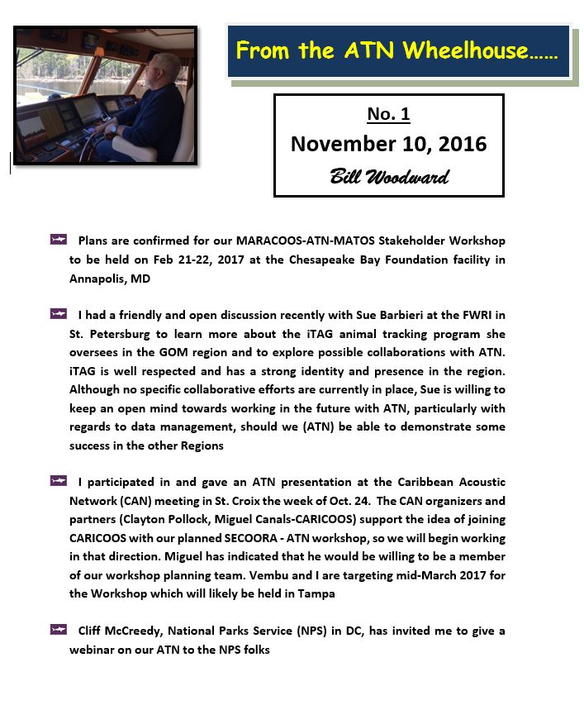

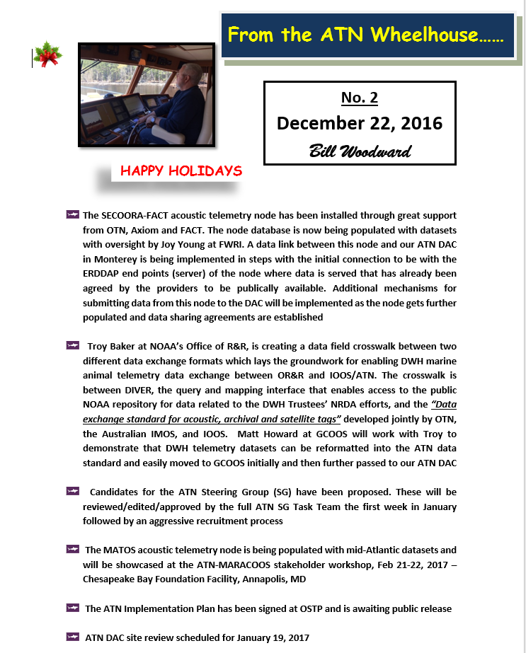

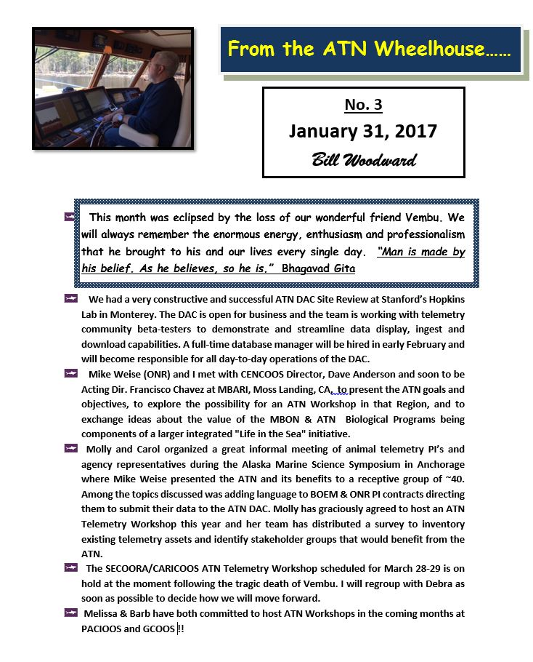

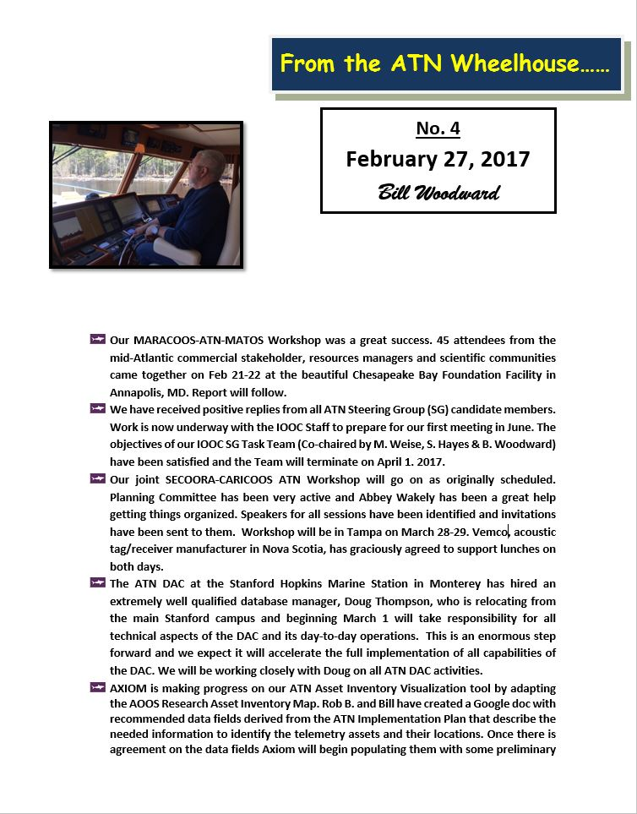
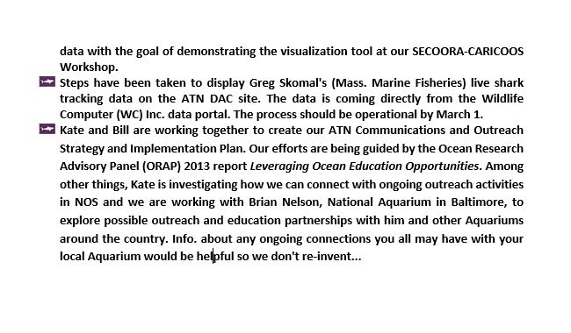

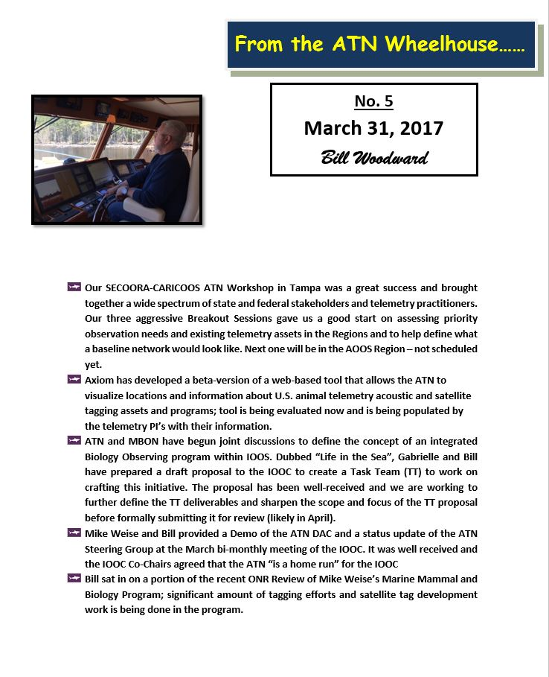

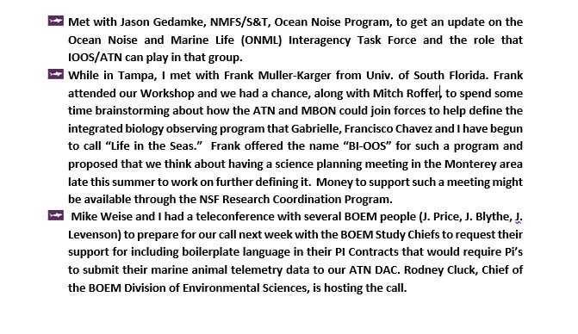

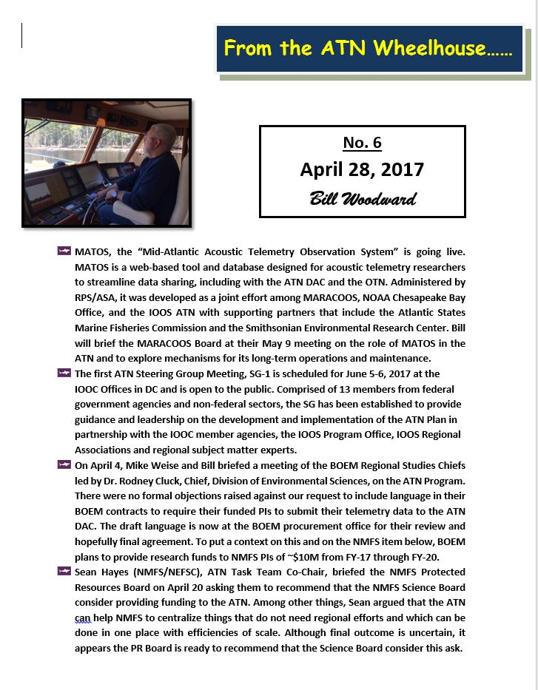

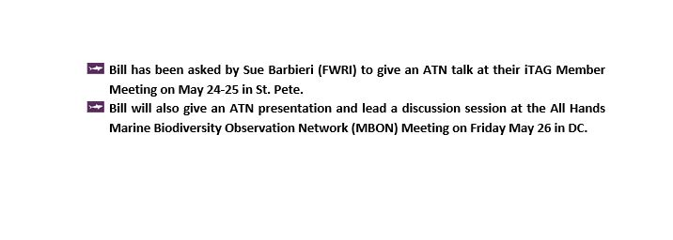

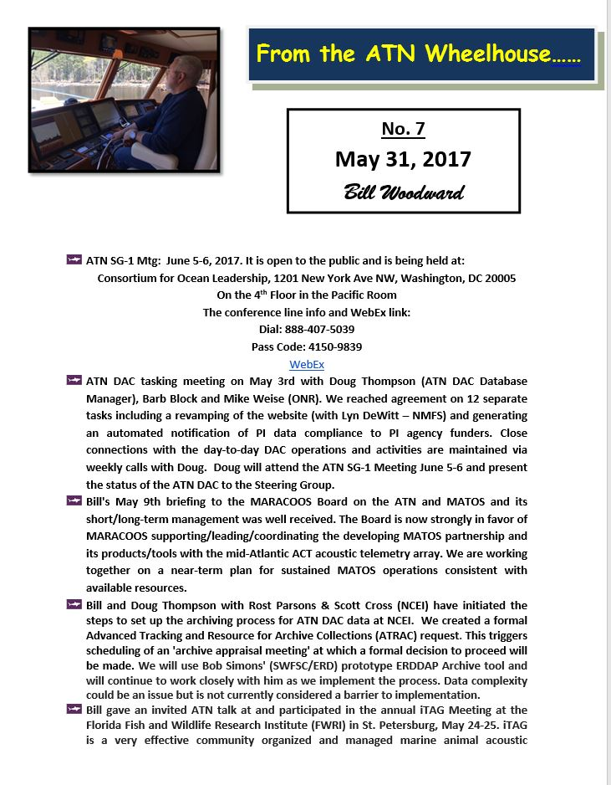

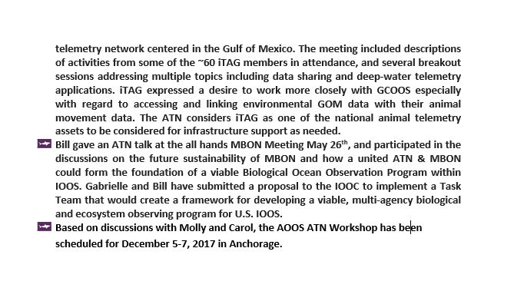

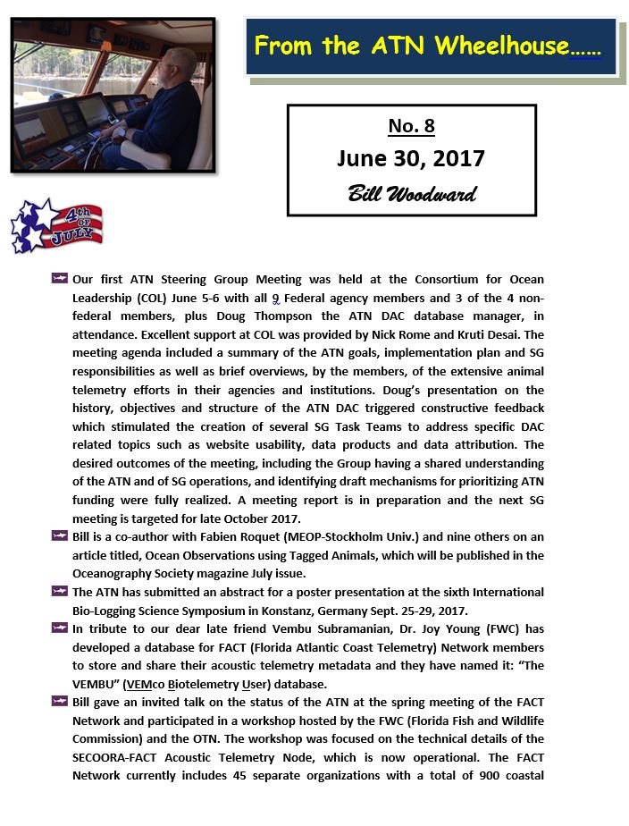

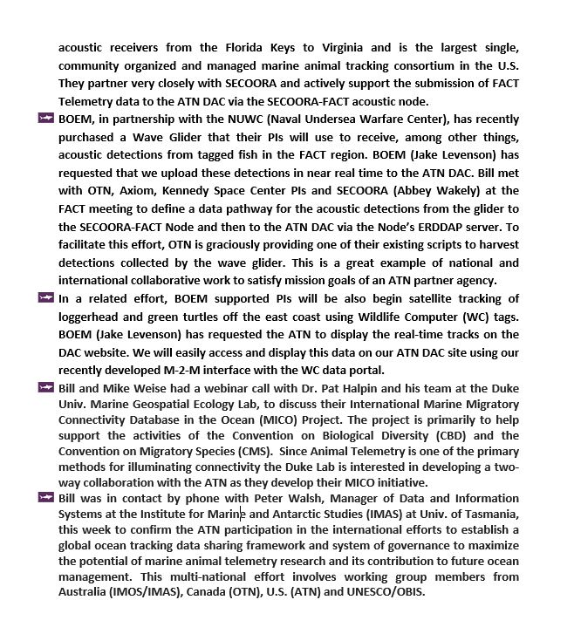

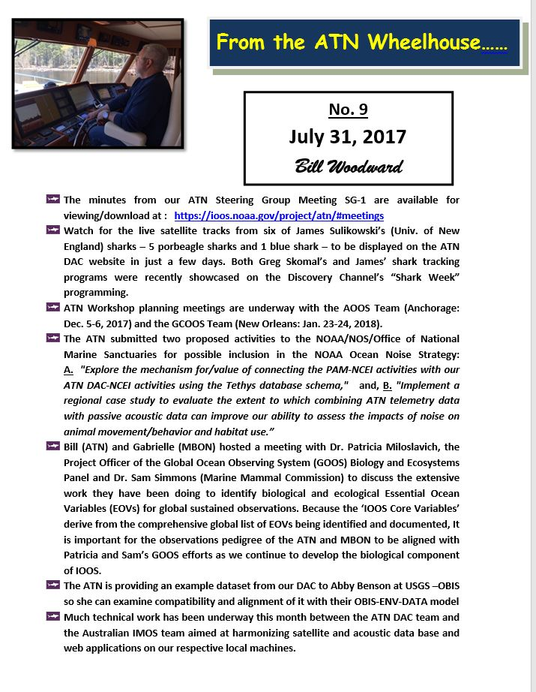

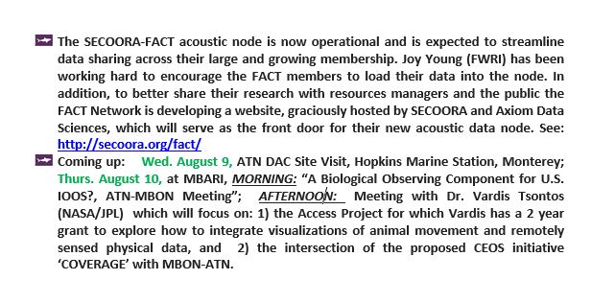

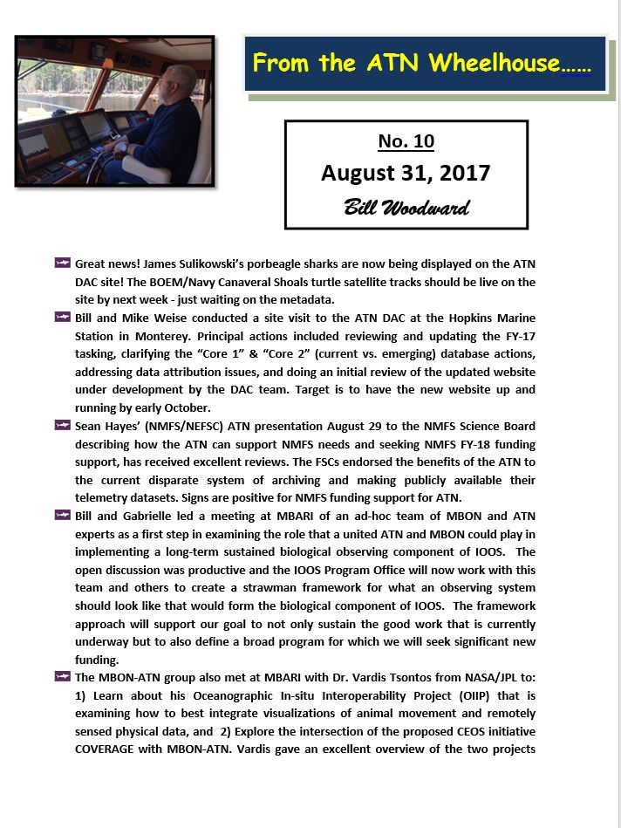
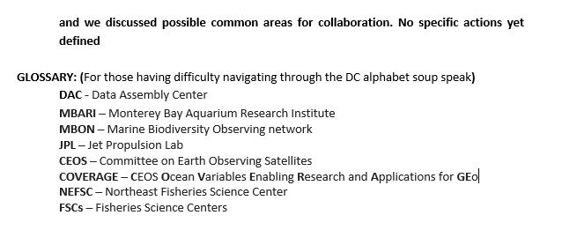

APPENDIX D

ATN NETWORK COORDINATOR TASKS

- Serve as the POC for the ATN though the IOOS Program Office
- Facilitate Communication & Information Exchange among
Parties Involved
- Coordinate Overarching Planning and Resource Management
- Facilitate, Develop & Support Multi-Agency and Institutional
Collaborations that Conduct and/or Promote Animal Telemetry
- Harmonize the Needs of the ATN SG, the IOOS PO,RA’s, and
Stakeholders
- Report to the IOOS OPS Div. Chief on Admin. Matters and to the
SG on All Programmatic Matters
- In coordination with the SG, lead the ongoing development of the overall ATN
- In coordination with the U.S. IOOS PO, support ATN implementation and pursue opportunities to advance ATN objectives
- Develop the annual operating plan and budget materials
- Support the SG and the interagency funding mechanisms
- Coordinate and ensure regular communication with the U.S. IOOS RAs and regional experts
- Serve as a liaison between all parties involved in the ATN, including the U.S. IOOS PO, U.S. IOOS, RAs, SG, Federal agencies, and regional experts
- Ensure that the ATN activities are integrated with other ocean
observing activities
- Track network performance metrics and report the results to the
SG and to U.S. IOOS PO leadership
- In coordination with the U.S. IOOS PO, oversee the DAC O&M,
which may be contracted to a third party
- Support data coordination and training
- Support outreach to the stakeholders and users

APPENDIX E
BILL WOODWARD ATN TRAVEL SUMMARY
 | CY-2016
May 12-13 | MARACOOS Mtg - Annapolis
May 16 | NMFS Sturgeon Mtg - W. Virginia
June 1-2 | OTN Symposium - Halifax, NS
June 10-11 | FACT Mtg - Jupiter FL
August 15-17 | NART Workshop - Fall River, MA
Oct 24-28 | iTAG Visit/USCAN - St. Pete/St. Croix
 | CY-2017
Jan 18-21 | DAC Site Review - Monterey, CA
Feb 20-22 | MATOS/MARACOOS-ATN Workshop - Annapolis
Feb 27-Mar 1 | GLATOS Mtg - Ann Arbor, MI
Mar 27-29 | SECOORA-CARICOOS ATN Wkshop- Tampa
April 3-5 | MARCO Workshop - Rutgers Univ - NJ
May 9-10 | MARACOOS Board/Meeting - Annapolis
May23-25 | iTAG Mtg - St. Pete, FL
June 22-23 | FACT Mtg - Jupiter FL
Aug 9-10 | DAC Site Visit + MBON-ATN - Monterey, CA
Sept 22- 29 | Biologging Symposium - Konstanz, Germany
Oct. 16-18 | IDMC MTG + OTN Symposium - Halifax
Dec 5-6 | AOOS ATN Workshop - Anchorage

